Strengthening the Foundations Workbook

KS3 Science

Hello!

Even in the best of times, not everything goes to plan. Things happen – things we cannot control - which affect our learning. It is nothing to worry about. We all have strengths and weaknesses; we all have to work hard to achieve our goals. Remember, your teachers know what you are good at and they know what you find difficult. They will support you.

In all subjects you learn at school, or college, there are important concepts and ideas which help you to understand a topic and provide the foundations for future learning. If you don’t have solid foundations, the rest of your knowledge will be unstable and not as secure as it could otherwise be.

The purpose of this workbook is to make sure your foundations are stable so that you can build the rest of your learning on it and have the strongest bank of knowledge and skills as possible.

Creating a stable foundation takes regular practice. We hope that this booklet will help you on your journey.

So, let’s practise!

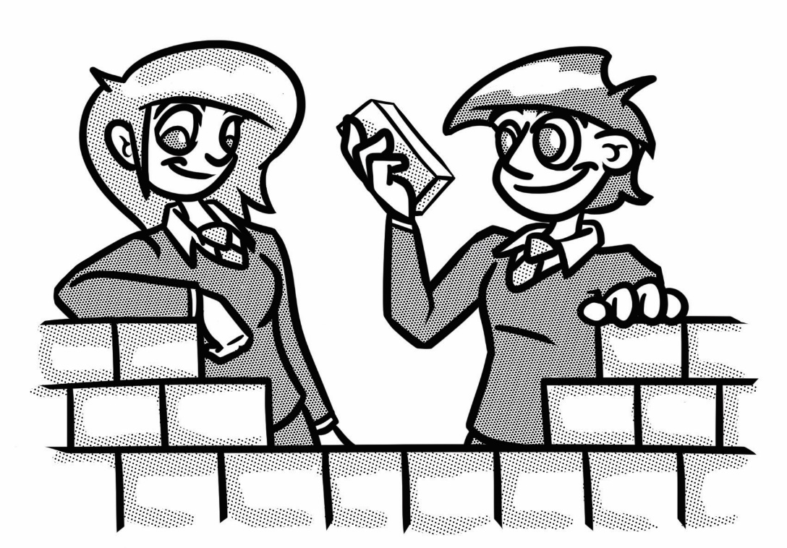

**How to use this booklet**

* Read the ‘recapping the foundations’ section of the booklet (see below). You can refer to this when you answer the questions.
* Answer the questions in the brick walls on pages 5 and 6 - start at the bottom of each wall.
* When you have answered the question in a brick, colour it in red, amber or green depending on how confident you feel.

**Recapping the foundations**

**Microscopes**



The **magnification** of an object on the stage is found by multiplying the magnification of the eyepiece lens by the magnification of the objective.

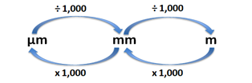

**Unit conversions:**

1 cm = 10 mm

There are 1000 µm in 1 mm.

**Changing state**

|  |  |  |  |  |
| --- | --- | --- | --- | --- |
| Solid | Melting | Liquid | Evaporating | Gas |
| Freezing | Condensing |

A solid melts when it is heated because the particles are gaining energy. This energy is used to break the forces of attraction between the molecules. The more energy a particle has the faster it can move.

**Separating techniques**

|  |  |  |  |
| --- | --- | --- | --- |
| **Filtration** | **Evaporation** | **Distillation** | **Chromatography** |
| Separates insoluble substances from a solvent. | Separates a **soluble** substance from a solution. | Separates a **liquid** or **solvent** from a mixture or solution. | Separates mixtures of **soluble** substances. |

**Solvent** = the liquid in which a solute dissolves

**Solute** = the substance that dissolves in a solvent to form a solution

**Solution** = the mixture formed when a solute has dissolved in a solvent

**Forces**

Some forces are contact forces, e.g. where the objects need to be touching each other. Examples of contact forces are friction, drag, upthrust, support (compression) and stretch (extension) forces. Some forces are non-contact forces, e.g. where the objects do not need to be touching each other. Examples of non-contact forces are gravitational force (gravity), magnetic force and electric force (static electricity).

**Distance – time graphs**

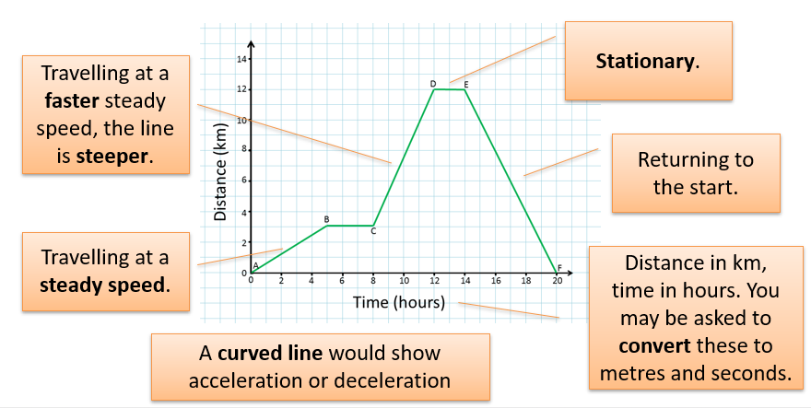

**Strengthening the foundations**

When a builder builds a brick wall, they start with the foundations at the bottom. On the wall below, the activities at the bottom are easier and they become more difficult as you move up the wall and build on the foundations you started with.

* Start with the activities at the bottom and work your way up the wall.
* RAG-rate each brick you complete by colouring it in red, amber or green to represent how confident you felt about that task.

|  |  |  |  |  |  |  |  |  |  |  |  |  |  |  |  |  |  |  |
| --- | --- | --- | --- | --- | --- | --- | --- | --- | --- | --- | --- | --- | --- | --- | --- | --- | --- | --- |
| Name the four specialised cells in **Box 3** on page 8. Complete the table. |  | Describe three steps on how to make a specimen slide for a **microscope**. What is the total **magnification** if the eyepiece lens is x10 and the objective is x20? |  | **Convert** the following units:   |  |  |  | | --- | --- | --- | | cm | mm | µm | | 1 |  |  | |  | 550 |  | |  |  | 3725 | |  | Complete **Question 3** on page 7. |

|  |  |  |  |  |  |  |
| --- | --- | --- | --- | --- | --- | --- |
| Write down three tips that you can use to identify whether a cell under a microscopeis from a **plant or an animal**? |  | What is found inside the **nucleus** of a cell? |  | Name the **process** happening in every cell. Write down the word equation for the process.  Use **Box 2** on page 7 to help. |  | Name the **process** which happens in plant cells containing chlorophyll. Write a word equation for this process. Use **Box 2** on page 7 to help. |

|  |  |  |  |  |  |  |
| --- | --- | --- | --- | --- | --- | --- |
| How do gases move into and out of a cell? What is this **process** called? Draw a diagram to show this process in action. |  | Complete **Question 1b** on page 6. |  | Name an **organ** in a potato plant. What is the function of this organ? |  | Draw a **food chain** of your choice and explain what the arrows represent. |

|  |  |  |  |  |  |  |
| --- | --- | --- | --- | --- | --- | --- |
| Organisms made from one cell are called unicellular. What are organisms made from many cells called? |  | Complete the labels and titles on the diagrams in **Question 1a** on page 6. |  | Write a definition for these terms: cell, tissue, organ, system and organism. Use **Box 1** on page 7 to help. |  | Complete **Question 2** on page 7. |

|  |  |  |  |  |  |  |
| --- | --- | --- | --- | --- | --- | --- |
| Explain how solids **melt** - in terms of energy and the forces between particles. |  | Rock salt contains sand and salt. Salt is soluble in water, sand is insoluble. Write a method to describe how you would **separate** this mixture. |  | **Speed = distance ÷ time**  An object travels 50 km in 10 s. Calculate the speed in m/s.  (There are 1000 m in 1 km) |  | Why does a person on the Moon **weigh** less than a person on the Earth, even though their **mass** is the same? |

|  |  |  |  |  |  |  |
| --- | --- | --- | --- | --- | --- | --- |
| Complete **Question 6** on page 9. |  | What **separating technique** would be used to separate:   * Salt from salty water * Water from salty water. |  | **Speed = distance ÷ time**  Calculate the distance travelled by an object travelling at 5 m/s for 20 s. Give the correct unit. |  | Complete **Question 7** on page 9. |

|  |  |  |  |  |  |  |
| --- | --- | --- | --- | --- | --- | --- |
| Describe how the **particles** move in a solid, a liquid and a gas. |  | State the name of the **process** in the following changes of state:   * Solid to liquid * Liquid to gas. |  | **Speed = distance ÷ time**  Calculate the average speed of an object travelling  5 metres in 20 seconds. Give the correct unit. |  | Complete **Question 5** on page 8. |

|  |  |  |  |  |  |  |
| --- | --- | --- | --- | --- | --- | --- |
| Draw diagrams showing how the **particles** are arranged in a solid, a liquid and a gas. |  | Complete **Question 4** on page 8. |  | What are the standard **units** for: force, time, energy and distance? |  | What is the difference between **contact and non-contact forces**? |

**Q1a**. Give each cell a title to show whether it is a plant or an animal cell.

cell

cell

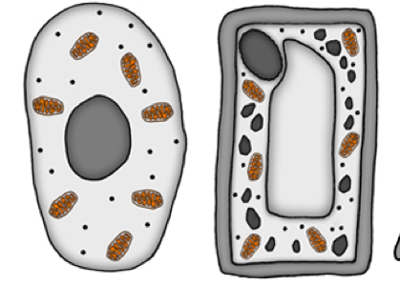

**b)** Match the parts of the cell to the correct function and then label the cells above.

|  |  |  |
| --- | --- | --- |
| **Nucleus** |  | Controls the cell |
| **Cell membrane** |  | Controls movement in and out of cell |
| **Cytoplasm** |  | Where chemical reactions happen |
| **Mitochondria** |  | Respiration |
| **Chloroplast** |  | Photosynthesis |
| **Cell wall** |  | Strengthens the cell |
| **Vacuole** |  | Filled with cell sap |

**Q2.** Sort out the following parts of the body by placing them under the correct heading:

Red blood cell, lining of the intestine, muscle cells, heart, kidney, lining of the lungs, artery, leaf, flower bud, nerve cell.

|  |  |  |
| --- | --- | --- |
| Cell | Tissue | Organ |
|  |  |  |

**Q3**. Look at the food web below.

1. What would the impact be on the snake and the rabbit populations if all the caterpillars died out? Explain why you think this might occur.
2. Primary means first. Consumer means to eat something. Which organisms are primary consumers in this food web?
3. Tertiary means third. Name the tertiary consumer/s in this food web.

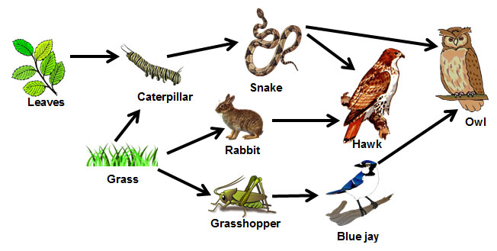

**Box 1**

Organisms with more than one cell are organised to help them be more efficient. A cell is the smallest unit of a living organism. Similar cells are often grouped together so they can do a particular job. Muscle tissue is made from muscle cells. Then, organs such as the heart or brain are organised from different tissues, such as nervous tissue, muscle tissue, etc. Organs work together in systems to do a particular function, such as in the nervous system, circulatory system, reproductive system, excretory system and digestive system.

**Box 3**

**Box 2**

Respiration and photosynthesis are often confused. Respiration occurs in every living cell and is required to transfer energy from glucose (found in food) to cells for use in other processes, such as making new molecules. When oxygen is combined with glucose, carbon dioxide and water are released as waste products. Plants and algae do not eat. They use energy from light, together with carbon dioxide and water, to make glucose through a process called photosynthesis.

|  |  |  |  |  |
| --- | --- | --- | --- | --- |
| Specialised cell |  |  |  |  |
| Name of cell and its role |  | Neurone  (nerve cell) |  |  |
| How is the cell adapted? | Larger surface area |  | Has no nucleus |  |
| How does this help the cell to do its job? |  |  |  |  |

**Q4**. Name the equipment on the bench below.

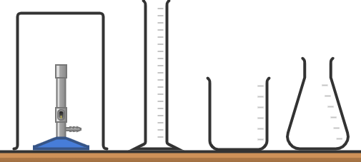

**Diagram made in** [**Chemix**](https://chemix.org/)

**Q5**. Look at the force diagram below.



250N

600N

* Calculate the resultant force.
* In which direction is the resultant force acting?
* Is the person travelling at a steady speed or accelerating?
* How do you know?

**Q6.** Look at this chromatogram from a chromatography experiment.

* Which dyes contain 3 colours?
* Explain why the line at the bottom is written in pencil.
* Why do you think some spots move up the paper further than others?

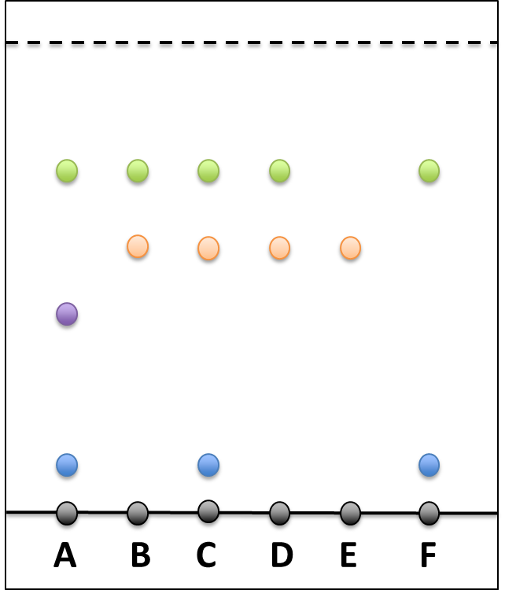

**Q7**. Look at this distance-time graph.

* When is the object moving at its slowest?
* What is happening between B and C?
* What distance had it travelled after 10 hours?
* Describe the journey in words.



**© Commissioned by The PiXL Club Ltd. July 2020**

This resource is strictly for the use by The PiXL Club Ltd member schools during the life of the membership only. It may NOT be copied, sold, or transferred or made available by whatever means to a third-party non-member during or after membership. Until such time it may be freely used within the PiXL member school by their teachers and authorized staff and any other use or sale thereof is strictly prohibited.

All opinions and contributions are those of the authors. The contents of this resource are not connected with, or endorsed by, any other company, organisation or institution.

PiXL Club Ltd endeavour to trace and contact copyright owners. If there are any inadvertent omissions or errors in the acknowledgements or usage, this is unintended and PiXL will remedy these on written notification.