Strengthening the
Foundations Workbook
KS4 English Literature

Students would benefit from having copies of their set texts, poetry anthology and unseen poems, if possible.

Hello!

Even in the best of times, not everything goes to plan. Things happen – things we cannot control – which affect our learning. It is nothing to worry about. We all have strengths and weaknesses; we all have to work hard to achieve our goals. Remember, your teachers know what you are good at and they know what you find difficult. They will support you.

In all subjects you learn at school, or college, there are important concepts and ideas which help you to understand a topic and provide the foundations for future learning. If you don’t have solid foundations, the rest of your knowledge will be unstable and not as secure as it could otherwise be.

The purpose of this workbook is to make sure your foundations are stable so that you can build the rest of your learning on it and have the strongest bank of knowledge and skills as possible.

Creating a stable foundation takes regular practice. We hope that this booklet will help you on your journey.

So, let’s practise!

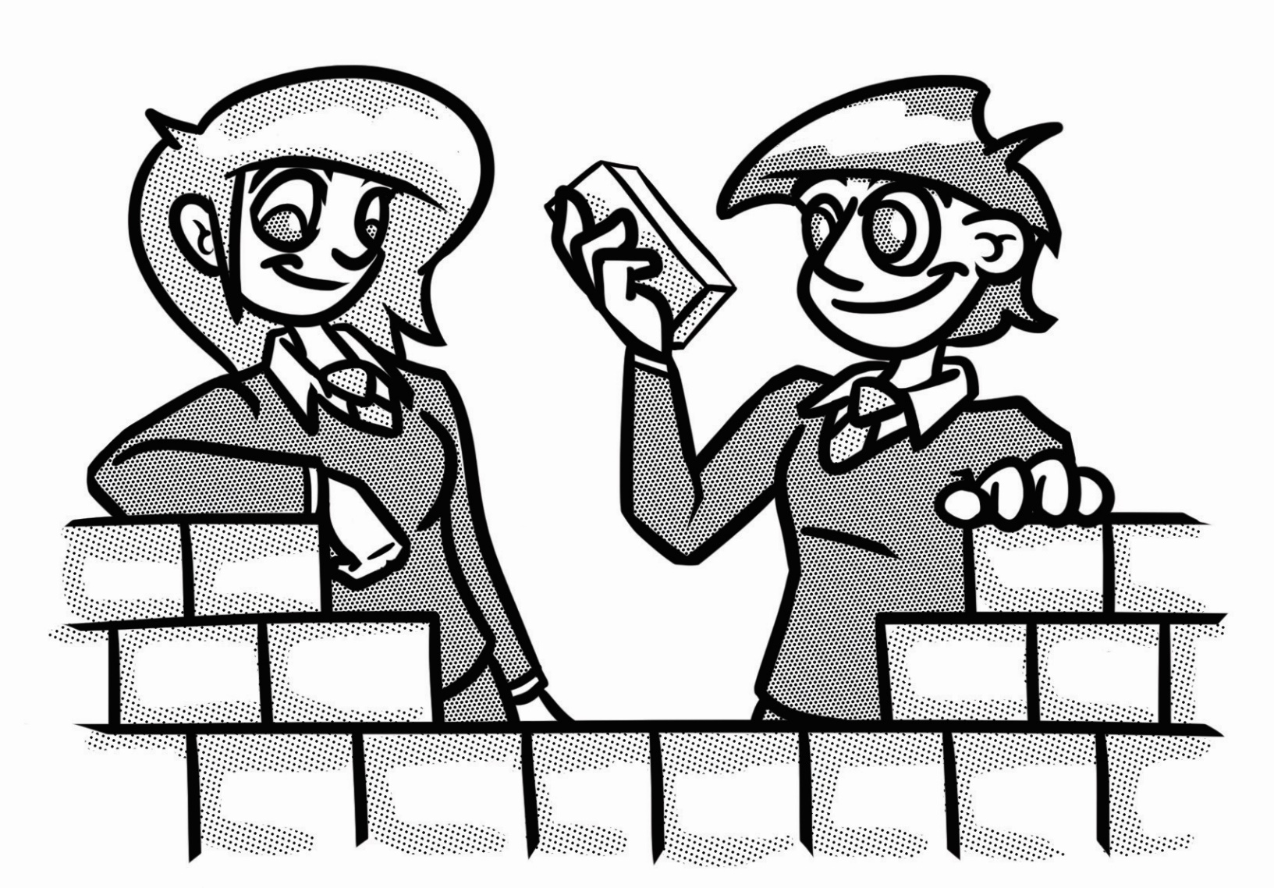

How to use this booklet:
- ‘Recapping the foundations’ offers support for some of the key foundational skills that will help you succeed. Read the sections you feel you need extra support on.
- Answer the questions in the brick walls on pages 7 and 8, start at the bottom of each wall. You can refer to recapping the foundations to help, if you need to.
- When you have answered the question in a brick, colour in red, amber or green depending how confident you feel.

Recapping the foundations

Knowing the set texts: plot, characters and themes
Having a strong knowledge of your set texts and poems from your anthology is the foundation for applying other skills such as analysis and developing an interpretation in response to a question. GCSE examiner reports highlight the importance of being able to place extracts into the context of the wider text and also being able to easily refer to key moments across the text to make thoughtful points in relation to the question.

By knowing your set texts thoroughly, you will be able to make links to themes, issues and characters and therefore see the text as a ‘construct’ – something the writer has created.

As well as this, it’s important to remember that the foundation is to know the text, not just the story. Examiner reports highlight that some students refer to film or TV versions of the texts and this leads to errors and lower-quality responses.

To help you work on this, re-read your set texts at least once. Each time we re-read, we notice new things we didn’t before; we gain a deeper understanding, consolidate our knowledge and are able to make more connections between characters, themes and events.

Read and understand questions
You may have heard most of your teachers stress the importance of reading the question; this seems obvious, doesn’t it? But every year, there are students who respond to a question that has not actually been asked because they have misread it. Your success in GCSE English Literature relies on you responding to a few questions with full, written responses. If you don’t read the question properly, or misunderstand it, you are unlikely to be as successful as you otherwise would have been. Under pressure in the exam, many students speed-read, think they’ve got the gist of the question, start writing (or do a bit of planning) and then go off on a tangent, completely miss the point of the question and therefore not get the marks they actually deserve.

To avoid this, the following tips may be useful to apply:
- Tip 1: BUG the question
  - Box the command word
  - Underline the key information you’re being asked to write about

  - Glance back at the question regularly as you write – it can be helpful to do this half way through a paragraph to quickly check you’ve not lost sight and started going off on a tangent. You should glance again at the end of each paragraph to make sure you round them off with a link back to the question.
- Tip 2: Plan for the question you’ve been given
  - Once you have applied Tip 1, you can create a plan that specifically addresses all points covered to help you in your writing.
- Tip 3: Check back at the end to edit
  - Just like the G in BUG tells you to glance back at the question regularly, leave time at the end to glance back and then read through your work to a) check for SPaG errors and b) to make sure you’ve really addressed the question, with time to write a brief conclusion that makes sure you end by fully addressing your response to the question.

Selecting relevant details
Selecting details from the text is a foundational skill you will probably have worked on in English lessons since Year 7. Being able to refer to details within the text, and select appropriate quotations to support your points, is key to developing a strong argument in your written work for literature, as well as language.

It is important to remember to:
- Select details from across the whole of the extract or poem, not just the opening.
- If you are asked to refer to the whole play as well, you shouldn’t just talk about the extract. This point links back to the previous foundation: being able to read and understand the question fully.
- If a question asks you to explore two points, make sure you address both issues. For example, it may ask you about attitudes two characters have to something, in which case you need to talk about both characters, and not just one.

It can be useful to highlight/underline details from an extract so that they stand out clearly as you read. Ignore any juicy details that are not relevant – you may be able to say a lot about them, but if it isn’t relevant for the question, it is not going to help you succeed.

Tip: If the question has more than one issue for you to underline, when you BUG the question, colour code your details by using the same colour highlighter to highlight quotes for each issue. Then, look back at the details you have highlighted across the extract. Do any link to the same point about an issue? If so, code them in some way – e.g. put a * next to ones that link to one point and + next to details that link to another point. Coding the details in this way will help when you come to plan as you’ll be developing your response by showing how these details support your point and develop what is happening.

Knowing the context – interpretation
Literature students are expected to show knowledge of the relationships between the text and the context in which it was written. Examiners want students to be free to adopt a broad interpretation of ‘context’, dependent on the text they are studying.

Some students misunderstand what ‘context’ means, so let’s recap this before moving on:
- The context(s) in which the text was written in
- The context(s) in which the text is set – location, social structures, culture, period of time etc.
- Literary context – for example, genre.

Let’s look at an example question from An Inspector Calls. This may not be your set text, but it will give you an idea of how to get started.
Change – so we need to talk about character development. We also need to think about why this change happens in the play and how this might link to the audience’s experiences at the time the play was performed and why they may also want to change (war, socialism, social responsibility).

How far does Priestley present Sheila as a character who changes her attitudes towards herself and others during the play?

Idea of social responsibility.
- Links to socialism.
When we look at others, we may consider her interaction with Eva which then links this idea to class and her attitude to people of other classes.
What do we know about Sheila? Think gender, class, responsibilities (or lack of), family environment – family pressures etc.

Structuring a written response – planning
Planning is a really important skill. This is the foundation for all of your extended written responses. Spending time planning means you are more likely to identify relevant ideas in response to the question, organise them in a clear way and present them effectively.
There are many ways you can plan (bullet points, spider diagrams, Venn diagrams etc) but essentially, when you plan a literature essay, you need to start with the following:
- Identify points and quotations that respond to the exact question you’ve been asked.
- Order these points into a clear and logical structure.

How and why writers use methods
You’ll have explored methods that writers use in their writing (also referred to as techniques, features or devices). These include language devices (such as simile, personification and pathetic fallacy) and structural ones (repetition or sentence structures).

Knowing methods is a key foundation for you to build on in English. However, the key here is that this knowledge is a foundation: something to build upon, and not a key skill alone.

You are not expected to ‘feature-spot’ (to look for techniques and simply say the writer has used them). The key to success, as you may have realised from reading other sections of this booklet, is that you respond to a question with your own interpretation by reading it carefully, selecting relevant details and then exploring these further. Identifying methods used should never be the driver of your essay.

Instead, we should be exploring how the writer presents ideas, characters and themes in a certain way and therefore why the writer uses the methods they do. Whilst many students can identify methods, they don’t always link these to the big ideas and contexts to explain how and why the writer is using them.

For example, a student may identify the image ‘ape-like fury’ which is used to describe Mr Hyde in The Carew Murder Case chapter of Dr Jekyll and Mr Hyde.
- Students might talk about the fact that ‘ape’ makes it sound like Hyde is an animal.
- They may also say that this might shock the reader.

These comments start to address how the quotation presents Hyde to the reader. What they don’t do is say why.
For example:
- Linking to Victorian social etiquette and expectations – the notion of gentleman and how Hyde does not fit this.
- Linking to the intellectual and religious aspects of context in the period the text was written with the publication of Darwin’s The Origin of Species. By linking to this, students can then develop their response to the effect that Hyde would have on the audience in light of the science vs religion debate that was being had in parts of society at the time.

Strengthening the foundations
When a builder builds a brick wall, they start with the foundations at the bottom. On the wall below, the activities at the bottom are easier and they become more difficult as you move up the wall and build on the foundations you started with.
- Start with the activities at the bottom and work your way up the wall. If they do not focus on your set text, they will be useful practice.
- RAG-rate each brick you complete by colouring it in red, amber or green to represent how confident you felt about that task.

Re-read your set cluster from the poetry anthology. Make a flashcard for each poem, with key points. |  | For each of the characters in your text/s, write why you think they have been created for the text. |  | ‘Literature is worthwhile because it teaches us things.’ Summarise the messages in your set texts. |  | Choose some unseen poems and create and respond to your own questions, suited to your exam board.

Most texts contain a significant moment that is crucial to the action. What is the defining plot moment in each of your set texts? |  | Complete the web activity in Task 4 (see page 10) by writing character names, making connections and explaining these along lines. |  | For each of the themes you’ve identified for your text/s, write why you think this theme has been incorporated into the text. |  | Create three questions for your set text/s. Write the indicative content for each (the key details to include in an essay in response).

Create a visual timeline, summary or storyboard to illustrate the plot. Make sure to include any subplots as well. |  | Complete the character quotation activity in Task 3 (see page 10) to help you revise the characters in your set text/s. |  | Complete the table activity in Task 5 (see page 10) by writing characters down one side and themes across the top. Make connections between these in the grid. |  | BUG the questions in Task 2 (see page 9). Please note, this may not be one of your set texts, but it is good practice for selecting details in response to a question.
Re-read your set text/s to re-familiarise yourself with the plot. As you go, note down key moments in bullet points. |  | List the main characters in each set text. Create flashcards/profiles for them. Include key events, quotes, relationships etc. |  | List the themes for each of your set texts. You may need to re-read these to ensure that you identify as many as possible. |  | Complete Task 1 (see page 9) by BUGing the questions provided. These may not be your set texts, but this is useful practice.

Select some unseen poems and practise selecting details which present the poet’s view or perspective about the subject matter of the poem. |  | Plan and write a response to a practice question, embedding context throughout your exploration: not writing it as a ‘bolt-on’. |  | Choose two poems on the same subject – e.g. war, love or nature. Plan and write an essay which compares how they present their views on the subject. |  | Using one of the extracts and plans you used/created for another task, consider the effect of the methods that you didn’t select for the plan you made.

Choose an extract from your set text/s. Create your own question based upon it. Write the indicative content that would be in the mark scheme for your question. |  | Look at past questions (or write your own) and mindmap or bullet point the ‘big ideas’ and contexts that link to the question and text. |  | Choose a descriptive extract (from a set text if possible, but you could practise with any text). Create a question and plan a detailed response to it. |  | A soliloquy is when a character speaks aloud to themselves on stage. Why might this be effective? Identify a soliloquy in a play you’ve studied.

Choose a descriptive extract (from a set text if possible). Select details from the extract which make the description effective. |  | Add details from your set text/s to your flashcard/mindmaps as evidence of how context impacts upon the text. |  | Use a Venn diagram to plan a comparison of two poems: |  | A protagonist is a leading character. An antagonist actively opposes someone. Identify these in your set text/s and consider why the antagonists were created.

Complete Task 2 (see page 9). Please note, this may not be one of your set texts, but it is good practice for selecting details in response to a question. |  | Consider what ‘contexts’ may be relevant for your set text/s. E.g. location, time period, religious beliefs, political issues etc. Create a flash card or mindmap. |  | Choose one of the questions in Task 2, or an alternative one you have access to, and create a plan with a clear structure. |  | Go through your exercise book and create a glossary/flash cards/game to help you to revise the methods you have been taught.

Task 1: Read and understand the question
BUG the questions below about Macbeth and Romeo and Juliet, and then create a plan for each one. Please note that you may not be studying these plays as your set text, but we have used them as an example because most students are familiar with them.
Starting with this moment in the play, explore how Shakespeare presents the attitudes of Macbeth and Banquo towards the supernatural.
Write about:
- how Shakespeare presents the attitudes of Macbeth and Banquo towards the supernatural in this extract
- how Shakespeare presents attitudes of Macbeth and Banquo towards the supernatural in the play as a whole.

Starting with this moment in the play, explore how Shakespeare presents relationships between adults and young people in Romeo and Juliet.
Write about:
- how Shakespeare presents relationships between adults and young people at this moment in the play
- how Shakespeare presents relationships between adults and young people in the play as a whole.

Task 2: Reading and understanding questions and selecting relevant details
Read the questions below; think carefully about the difference between the two. Identify relevant details for each one from the extract below, using a different colour for each.
- Starting with this extract, explore how Stevenson presents Mr Hyde.
- Starting with this extract, explore Utterson’s feelings towards Mr Hyde.
‘Come,’ said Mr. Utterson, ‘that is not fitting language.’
The other snarled aloud into a savage laugh; and the next moment, with extraordinary quickness, he had unlocked the door and disappeared into the house.
The lawyer stood a while when Mr. Hyde had left him, the picture of disquietude. Then he began slowly to mount the street, pausing every step or two and putting his hand to his brow like a man in mental perplexity. The problem he was thus debating as he walked, was one of a class that is rarely solved. Mr. Hyde was pale and dwarfish, he gave an impression of deformity without any nameable malformation, he had a displeasing smile, he had borne himself to the lawyer with a sort of murderous mixture of timidity and boldness, and he spoke with a husky, whispering and somewhat broken voice; all these were points against him, but not all of these together could explain the hitherto un- known disgust, loathing, and fear with which Mr. Utterson regarded him. ‘There must be something else,’ said the perplexed gentleman. ‘There is some- thing more, if I could find a name for it. God bless me, the man seems hardly human! Something troglodytic, shall we say? or can it be the old story of Dr. Fell? or Is it the mere radiance of a foul soul that thus transpires through, and transfigures, its clay continent? The last, I think; for, O my poor old Harry Jekyll, if ever I read Satan’s signature upon a face, it Is on that of your new friend.’

Task 3: Revising characters
Draw an outline of a gingerbread person. Choose a character from one of your set texts follow the guidance below:
- Inside the gingerbread person, write quotations which are said by the character which reveal something about their character
- Around the outside of the gingerbread person, write quotations which are said by other characters to, or about, the character which reveal how they are treated or seen by others.
- For any comments that are descriptive or in stage directions, decide where you feel these would be best placed.
- Consider these quotes – how are the ones inside different to those outside?
You could repeat this for any characters in any of your set texts.

Task 4: Revising characters and their connections to others
- On a blank piece of paper, write the character names across the page.
- Draw lines between characters who have close relationships or connections.
- Along each line, write an explanation of the relevance of the connection. You could include a quotation which exemplifies this, if you wish.
See the Revisit template below to see how you could start to lay this out.
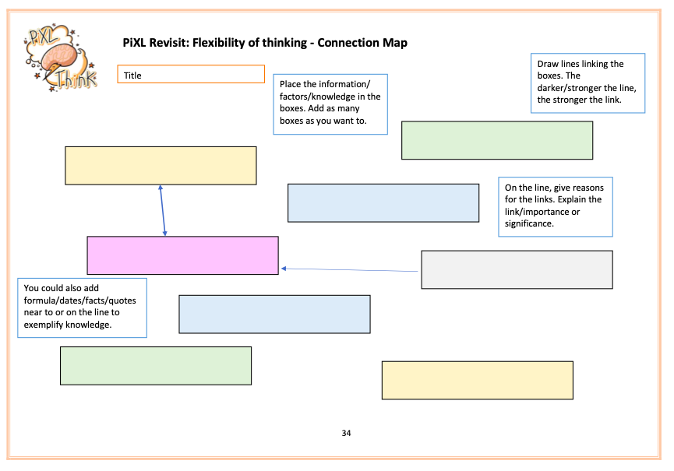

Task 5: Revising themes and characters
Create a table for each of your set texts. Down the side, write the names of the main characters. Across the top, write the themes that appear in that text. Once you have done this, fill in the grid, making connections between each character and the relevant themes they link to. You may not need to fill in every box, but this is a useful way to revise how characters link to different themes. It therefore helps you to see the text as a construct, rather than just a story. For example:
Blood Brothers | Class | Coming of age | Superstition
Mickey
Edward
Linda

© Commissioned by The PiXL Club Ltd. July 2020

This resource is strictly for the use by The PiXL Club Ltd member schools during the life of the membership only. It may NOT be copied, sold, or transferred or made available by whatever means to a third-party non-member during or after membership. Until such time it may be freely used within the PiXL member school by their teachers and authorized staff and any other use or sale thereof is strictly prohibited.

All opinions and contributions are those of the authors. The contents of this resource are not connected with, or endorsed by, any other company, organisation or institution.

PiXL Club Ltd endeavour to trace and contact copyright owners. If there are any inadvertent omissions or errors in the acknowledgements or usage, this is unintended and PiXL will remedy these on written notification.

