Strengthening the Foundations Workbook
KS4 Foundation Maths

Hello!

Even in the best of times, not everything goes to plan. Things happen – things we cannot control - which affect our learning. It is nothing to worry about. We all have strengths and weaknesses; we all have to work hard to achieve our goals. Remember, your teachers know what you are good at and they know what you find difficult. They will support you.

In all subjects you learn at school, or college, there are important concepts and ideas which help you to understand a topic and provide the foundations for future learning. If you don’t have solid foundations, the rest of your knowledge will be unstable and not as secure as it could otherwise be.

The purpose of this workbook is to make sure your foundations are stable so that you can build the rest of your learning on it and have the strongest bank of knowledge and skills as possible.

Creating a stable foundation takes regular practice. We hope that this booklet will help you on your journey.

So, let’s practise!

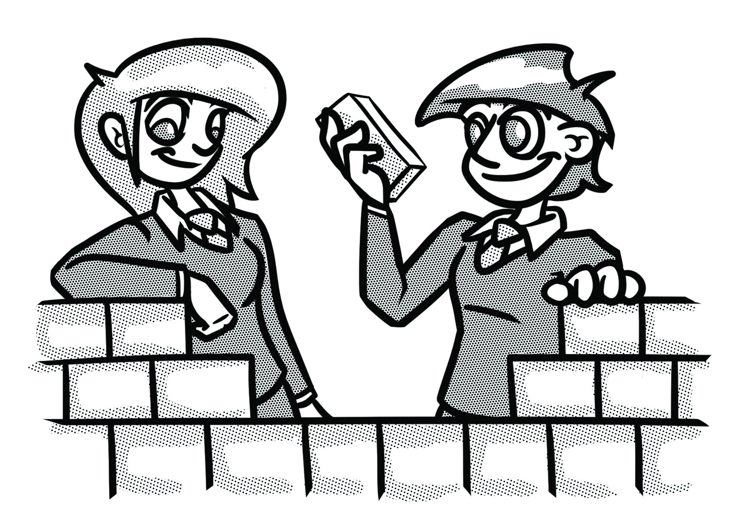

How to use this booklet
- Read the ‘recapping the foundations’ section of the booklet (see below). You can refer to this when you answer the questions.
- Answer the questions in the brick walls on pages 5 and 6 - start at the bottom of each wall.
- When you have answered the question in a brick, colour it in red, amber or green depending how confident you feel.

Recapping the foundations

Adding and subtracting fractions

In order to add and subtract fractions with a different denominator, we must first convert the fractions so that they have the same denominator.
Sometimes, fractions don’t have a common denominator. If this is the case, we must first convert the fractions so that they do have a common denominator.

We CANNOT add fractions which do not have the same denominator.

Let’s look at some examples:
$$\frac{5}{16} + \frac{1}{8}$$

Before we can add these fractions, we must make sure they have a common denominator. To do this, we need to find the lowest common multiple of the denominators.
The lowest common multiple is the lowest number that both numbers go into.
The lowest common multiple of 16 and 8 is 16.
x2

$$\frac{1}{8}= \frac{2}{16}$$

x2

$$\frac{5}{16} + \frac{2}{16} = \frac{7}{16}$$

Equivalence
Divide numerator by denominator
Decimal
Fraction

Multiply by 100
Write out of 100

Percentage

Using scales in real life

Remember: Ratio is a way of comparing quantities.
A very important use of ratios is in scale. When using scale, ratio is used to compare the length of a drawing or a model to the length of the real thing.
It is important, when using scale, that both amounts being compared are in the same units and that the ratio is simplified to the lowest terms.

A model car is made to a scale of 1:30. If the length of the model car is 15 cm, how long is the actual car?

- The scale 1:30 means that every unit of measurement of the model is 30 units of measurement on the actual car. For example, every 1 cm of the model is 30 cm on the actual car. In other words, the measurement of the actual car is 30 times bigger than any measurement on the model.
- We are told that the length of the model car is 15 cm. To find the length of the actual car, we therefore need to multiply this by 30.
- 15 x 30 = 450 cm or 4 metres and 50 cm or 4½ metres.

Proportion

To solve problems with direct proportion, you can start by finding the value of 1 unit.

E.g. The cost of 4 toilet rolls is £1.20. How much will 3 toilet rolls cost?
$$×3$$
$$×3$$
$$÷4$$
$$÷4$$
4 | 1.20
1 | 0.30
3 | 0.90

Strengthening the foundations
When a builder builds a brick wall, they start with the foundations at the bottom. On the wall below, the activities at the bottom are easier and they become more difficult as you move up the wall and build on the foundations you started with.
- Start with the activities at the bottom and work your way up the wall.
- RAG-rate each brick you complete by colouring it in red, amber or green to represent how confident you felt about that task.

Write five revision cards on key points to remember for fractions, decimals and percentages. Rank the information in order of difficulty. |  | Complete ‘Question 1’ on page 7. |  | Complete ‘Question 2’ on page 7. |  | Complete ‘Question 3’ on page 8.

Write five questions with marks schemes on ordering fractions and decimals. Your questions must include at least one improper fraction. |  | Write an end of topic test on fractions, decimals and percentages. |  | Show three ways you can represent a fraction and write an explanation for each. |  | Explain three common mistakes made by students when calculating with fractions.

Explain how to convert between an improper fraction and a mixed number. Give three examples and draw a picture. |  | Evan scores 74% in his German exam. Bilal gets 60 out 80. Who did better? Explain your answer. |  | Create a flow diagram on how to convert between fractions, decimals and percentages. |  | Explain the differences and similarities between rounding to one decimal place and to one significant figure.
Write the following in descending order:  ¾, 0.3, 35% |  | Convert 16 out of 40 to a percentage and decimal. |  | Round the following to one decimal place:  0.765, 1.98, 3.456, 1.233 |  | Write a question with $\frac{2}{3}$ as the answer.

Make a scale drawing of a room in your house, include the area of the walls and calculate the volume. |  | Complete ‘Question 4’ on page 7. |  | Find the exchange rates for four different countries and write an explanation about how to convert £120 into each currency. |  | Complete ‘Question 5’ on page 7.

Joe makes a model of a house. All the measurements of the actual house are ten times bigger than the measurements of the model. What is the scale of his model? |  | $$5 miles≈8 kilometres$$  Use the information above to decide who has travelled furthest:  Uzma ran 8 miles.  Janet ran 10 kilometres. |  | It takes 12 people 6 hours to chop down the trees in the field. How long would it take 18 people? |  | 1 foot = 12 inches.  Andy is 74inches tall. How tall is Andy in feet and inches?

An aeroplane has a wingspan of 70 metres. A model of it is made on a scale of 1:50. How big is the wingspan on the model? |  | A model of the Big Ben clock tower is 200 times smaller than the real thing. Write this as a ratio. |  | Write an explanation on how to find the answer to one of the questions on the bottom row. |  | 4 litres of paint costs £7. How much will 13 litres cost?

3 pens cost £0.45, how much will 7 pens cost? |  | What two inverse operations could you use to check the calculation is correct?  $$1512÷54=28$$ |  | Share 27 in the ratio 1:2. |  | Write the fraction $\frac{4}{7}$as a ratio.

Questions

Question 1.
In maths it is crucial that we have a way of checking our answers. That might involve ‘undoing’ the calculation, checking that the answer seems reasonable or working backwards.
The following questions all have the answer $\frac{2}{5}$. Can you work out what is missing?
A grid with 15 squares has ___ shaded in. What fraction of the shape is unshaded?

Write ____ % as a fraction?
Which is bigger _____ or $\frac{2}{5}$?
Jordan is reading a book on his e-reader. When he picks it up, it tells him he is $\frac{1}{4}$ of the way through the book. He reads some more. When he checks again, he is now ____% of the way through the book. What fraction of the book did he read?
The answer is $\frac{2}{5}$

Question 2.

Using fractions, write a question for the diagram below.

Question 3.

$\frac{1}{3}$ of a teacher’s class want to play football. There are 27 pupils in the class. How many don’t want to play football? (Can you also represent this question as a bar model?)

Question 4.
In maths it is crucial that we have a way of checking our answers. That might involve ‘undoing’ the calculation, checking that the answer seems reasonable or working backwards.
Fill in the gaps, using a method of checking show the answer is still 2:3.
Jenny and Rickma share some sweets. Jenny has 12 sweets, Rickma has ____. Give the ratio of their sweets in its simplest form.
Jenny and Rickma share ____ sweets. Rickma has 9 more sweets than Jenny. Jenny has ___. What is the ratio of sweets?
Jenny and Rickma share ___ sweets. Jenny has ___ and Rickma has 15. What is the ratio of sweets?
Jenny and Rickma share some sweets. Jenny has $\frac{?}{?}$ of the sweets. Write the ratio of sweets.
The answer is 2:3

Question 5.
Write a question and mark scheme for the diagram below.
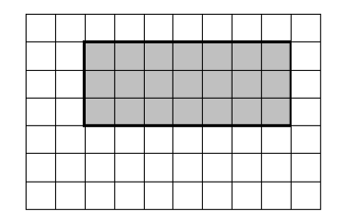Scale 1:40

© Commissioned by The PiXL Club Ltd. July 2020

This resource is strictly for the use by The PiXL Club Ltd member schools during the life of the membership only. It may NOT be copied, sold, or transferred or made available by whatever means to a third-party non-member during or after membership. Until such time it may be freely used within the PiXL member school by their teachers and authorized staff and any other use or sale thereof is strictly prohibited.

All opinions and contributions are those of the authors. The contents of this resource are not connected with, or endorsed by, any other company, organisation or institution.

PiXL Club Ltd endeavour to trace and contact copyright owners. If there are any inadvertent omissions or errors in the acknowledgements or usage, this is unintended and PiXL will remedy these on written notification.

