Strengthening the Foundations Workbook

KS4 Biology

Hello!

Even in the best of times, not everything goes to plan. Things happen – things we cannot control - which affect our learning. It is nothing to worry about. We all have strengths and weaknesses; we all have to work hard to achieve our goals. Remember, your teachers know what you are good at and they know what you find difficult. They will support you.

In all subjects you learn at school, or college, there are important concepts and ideas which help you to understand a topic and provide the foundations for future learning. If you don’t have solid foundations, the rest of your knowledge will be unstable and not as secure as it could otherwise be.

The purpose of this workbook is to make sure your foundations are stable so that you can build the rest of your learning on it and have the strongest bank of knowledge and skills as possible.

Creating a stable foundation takes regular practice. We hope that this booklet will help you on your journey.

So, let’s practise!

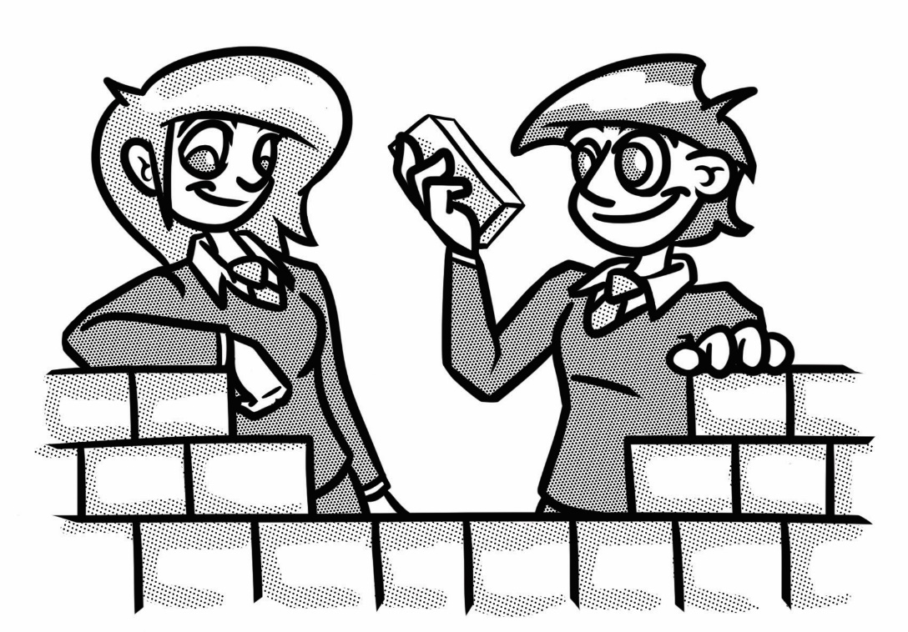

**How to use this booklet**

* Read the ‘recapping the foundations’ section of the booklet (see below). You can refer to this when you answer the questions.
* Answer the questions in the brick walls on pages 5 and 6 - start at the bottom of each wall.
* When you have answered the question in a brick, colour it in red, amber or green depending how confident you feel.

**Recapping the foundations**

**Maths in biology**

**Magnification**

Magnification is calculated by dividing the image size by the actual size of the object.

**Worked example:**

**An object was 10 µm and the image size was 5000 µm. Calculate the magnification.**

**Magnification = $\frac{image size}{actual size}$**

**Magnification = $\frac{5000}{10}$**

**= x 500**

**Unit conversions**

|  |  |  |
| --- | --- | --- |
| Prefix | Multiple | Standard form |
| **centi (cm)** | 1 cm = 0.01 m | x 10 -2 |
| **milli (mm)** | 1 mm = 0.001 m | x 10 -3 |
| **micro (𝛍m)** | 1 𝛍m **=** 0.000 001 m | x 10 -6 |
| **nano (nm)** | 1 nm = 0.000 000 001 m | x 10 -9 |

**Percentage change**

It is useful to calculate percentage change, rather than a change in mass or temperature, because it helps us to easily compare different results, even if the starting mass or temperature is slightly different.

% change = (change ÷ original) x 100

**Worked example:**

A student cut chips from a potato. These were weighed and placed in solutions of different concentrations of salt for an hour. The chips were dried carefully and reweighed.

The start mass was 2.6g. The final mass was 2.7g

What was the percentage increase?

The change in mass was 2.7 – 2.6g = 0.1g

% change = (change ÷ original) x 100

= (0.1 ÷ 2.6) x100

*On the calculator this will read 3.846153846153846153846153846153*

The original measurements were made to 1 decimal place on the balance so this is what should be used for the answer.

The answer would be rounded to **+3.8.** The ‘+’ indicates that the mass has increased.

Whereas, a ‘-’ sign would indicate that mass had been lost overall.

**Finding averages**

There are three types of average: the **mode**, the **median** and (the most important and widely used of the three) the **mean**. Find each as follows:

**mode: the most frequently occurring value**

**median: put the data in numerical order, then choose the middle one**

$$mean=\frac{total of items of data}{number of items of data}$$

**Worked example 1**

Find the mode, median and mean of 5 , 7 , 3 , 6 , 11 , 6 , 7 , 7.

**Mode is 7**

In order: 3 , 5 , 6 , 6 , 7 , 7 , 7 , 11

**Median is 6.5** (half way between the two middle values, 6 and 7)

Total of items of data: 5 + 7 + 3 + 6 + 11 + 6 + 7 + 7 = 52

$$\frac{52 }{8}= 6.5$$

**Mean = 6.5**

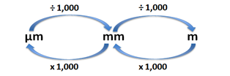**Converting units**

1000 cm3 = 1 dm3

cm3 ÷ 1000 = dm3

dm3 x 1000 = cm3

**Water transport in plants**

Water and mineral ions enter the roots from the soil via osmosis and active uptake. Root hair cells are specially adapted for this due to their shape. Xylem tissue transports water and mineral ions from the roots to the stems and leaves. The water column helps with support for small plants.

Xylem cells die and form hollow tubes which are strengthened by lignin. Lignin is waterproof.



Water leaves the leaf through the stomata by transpiration. The rate of transpiration is increased as the environmental temperature and air movement increase. If humidity increases then the rate of transpiration slows as the air becomes saturated with water vapour. So warm, windy and dry days increase the rate of water loss from a plant.

Osmosis is the movement of water from an area of high concentration to one of low concentration through a partially permeable membrane. Active uptake requires energy from respiration to pump mineral ions against the concentration gradient into the plant cells.



**A potometer**

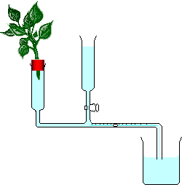

<https://commons.wikimedia.org/w/index.php?curid=1110424>

**Keeping things constant**

The human body needs to be controlled. Things like the amount of blood glucose, body temperature, pH, hormones and amount of water need to be kept at an optimum level.

Homeostasis means keeping things the same.

If the internal environment changes too much then enzymes may stop functioning effectively.

When you have a diet rich in protein, the excess proteins are digested into smaller amino acids. These travel in the blood to the liver where deamination occurs. This produces ammonia which is highly toxic. The body converts it to urea and this is removed from the blood in the kidneys. Urea is diluted with water to form urine and this is excreted from the body.

**Strengthening the foundations**

When a builder builds a brick wall, they start with the foundations at the bottom. On the wall below, the activities at the bottom are easier and they become more difficult as you move up the wall and build on the foundations you started with.

* Start with the activities at the bottom and work your way up the wall.
* RAG-rate each brick you complete by colouring it in red, amber or green to represent how confident you felt about that task.

|  |  |  |  |  |  |  |
| --- | --- | --- | --- | --- | --- | --- |
| Complete **Question 1** on page 9. |  | A student used five quadrats to count the number of daisy plants in an area. The results were 11, 8, 11, 9, 1. What was the **modal** result? |  | Why is it better to calculate **% change** rather than a change in mass? |  | Calculate the **actual size** of an object when the **magnification** is X400 and the **image** is 6mm. |

|  |  |  |  |  |  |  |
| --- | --- | --- | --- | --- | --- | --- |
| Calculate the **percentage** change in mass:  a) Start = 1.2g End = 1.8g  b) Start = 3.2g End = 2.7g  c) Start = 2.1g End = 2.8g |  | Calculate the **percentage** decrease:  Start mass = 1.6g  Final mass = 1.3g |  | Find the **mean** and the **median** of the following data:  12, 19, 28, 14, 42 |  | Find the **mean** of the following data:  4.2, 5.8, 0.6, -1.8, 6.4, -2.6 |

|  |  |  |  |  |  |  |
| --- | --- | --- | --- | --- | --- | --- |
| Calculate the **magnification**:  a) Image size = 1000 µm Actual size = 10 µm  b) Image size = 5mm and Actual size = 15 µm |  | Calculate the **percentage** increase:  Start mass = 1.7g  Final mass = 1.9g |  | State the **equation** for calculating percentage change. |  | How is the **mean** calculated from a set of data?  How is the **median** and the **mode** calculated? |

|  |  |  |  |  |  |  |
| --- | --- | --- | --- | --- | --- | --- |
| a) **Convert** 10 mm into µm.  b)Convert 1m into mm.  c)Convert 100mm into m.  d)Convert 100nm into µm. |  | State the **equation** which links magnification, image size and actual size. |  | What does the word ‘**percent**’ mean? |  | a) **Convert** 57 µm into nm.  b) Convert 5m into nm.  c) Convert 100mm into nm. |

|  |  |  |  |  |  |  |
| --- | --- | --- | --- | --- | --- | --- |
| 99% of the water which enters the root of a plant will leave by **transpiration**. What is the purpose of transpiration? |  | When the rate of **transpiration** is high and there is not much soil water available, a plant will wilt. Explain why this helps the plant survive for longer. |  | Why are there more **mitochondria** present in root hair cells than in other root cells? |  | Linnaeus used seven groups to **classify** living things. Put them in order, starting with the largest: genus, family, kingdom, phylum, species, class, order. |

|  |  |  |  |  |  |  |
| --- | --- | --- | --- | --- | --- | --- |
| What is a **potometer** used for? |  | Aerobic **respiration** occurs in an organelle in the cytoplasm of the cell.  What is this organelle called? |  | What is the role of the **bicuspid valve**? It is also called an atrio-ventricular valve. |  | Complete **Question 3** on page 10. |

|  |  |  |  |  |  |  |
| --- | --- | --- | --- | --- | --- | --- |
| What are the conditions which will lead to a low rate of **transpiration** from a plant? |  | What is this photograph showing? |  | **Higher Tier:** We cannot store excess protein so it must be **excreted**. What does the term ‘excreted’ mean? |  | Complete **Question 2** on page 9. |

|  |  |  |  |  |  |  |
| --- | --- | --- | --- | --- | --- | --- |
| What is the role of the **xylem** tissue in a plant? |  | How are root hair cells **adapted** for their role? |  | Define **osmosis**. |  | There are many processes in the human body which try to keep important substances and body temperature constant. What is this called? |

**Question 1.**

The table shows the percentage of some minerals in seawater, river water and rainwater.

|  |  |  |  |
| --- | --- | --- | --- |
| **Mineral** | **Seawater** | **River water** | **Rainwater** |
| Chloride | 1.90% | 0.04% | 0.01% |
| Sodium | 1.05% | 0.02% | 0.01% |
| Magnesium | 0.12% | 0.01% | 0 |
| Sulfur | 0.08% | 0.03% | 0 |

**(a)** Find the mean percentage of sodium in the three types of water.

**(b)** Find the mean percentage of sulfur in the three types of water.

**(c)** Approximately 96% of the water on Earth is seawater.

What percentage of water on Earth is chloride?

Circle your answer.

0.01% 0.65% 0.95% 1.88%

**Question 2.**

Correctly label W, X, Y and Z on the diagram of the heart.

The words in the box below may help.

Vena cava (sends deoxygenated blood into the heart)

Pulmonary vein (delivers oxygenated blood into the left atrium)

Pulmonary artery (delivers oxygenated blood to the lungs)

Aorta (sends oxygenated blood to the body)

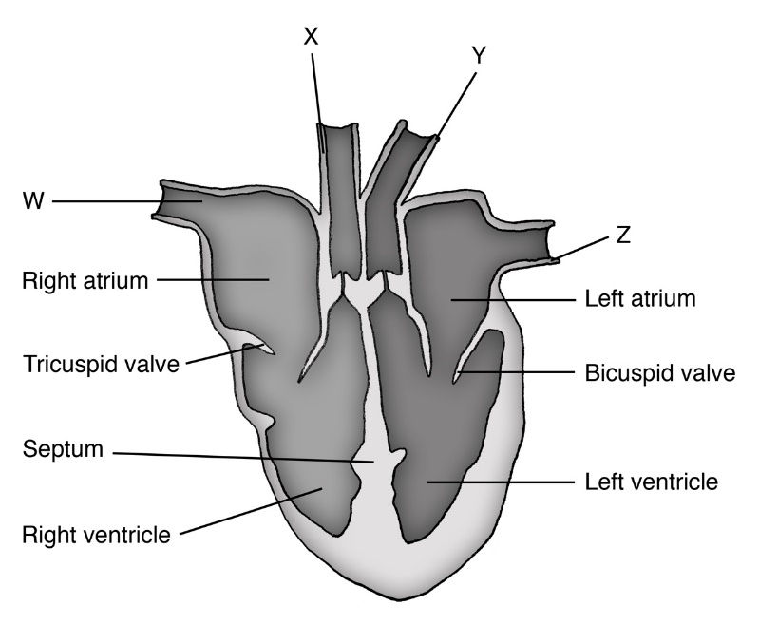

**Question 3**.

Coronary heart disease (CHD) can be caused by many factors. Layers of fatty material build up in the coronary artery.

The table below shows data related to CHD for five countries.

|  |  |  |  |  |  |
| --- | --- | --- | --- | --- | --- |
|  | **Country** | **Number of deaths from CHD per 100 000 population per year** | **Percentage of the population who smoke tobacco** | **Percentage of the population who drink alcohol heavily** | **Amount of fruit and vegetables eaten in kg per person per year** |
|  | **A** | 279 | 38 | 20 | 186 |
|  | **B** | 254 | 64 | 35 | 408 |
|  | **C** | 182 | 4 | 37 | 257 |
|  | **D** | 151 | 24 | 35 | 217 |
|  | **E** | 123 | 28 | 14 | 221 |

**(a)** Name **one** risk factor for CHD that is **not** shown in the table above.

**(b)** A student concludes that the main cause of CHD is not eating enough fruit and vegetables. Give two reasons why the student’s conclusion is not correct.

**© Commissioned by The PiXL Club Ltd. July 2020**

This resource is strictly for the use by The PiXL Club Ltd member schools during the life of the membership only. It may NOT be copied, sold, or transferred or made available by whatever means to a third-party non-member during or after membership. Until such time it may be freely used within the PiXL member school by their teachers and authorized staff and any other use or sale thereof is strictly prohibited.

All opinions and contributions are those of the authors. The contents of this resource are not connected with, or endorsed by, any other company, organisation or institution.

PiXL Club Ltd endeavour to trace and contact copyright owners. If there are any inadvertent omissions or errors in the acknowledgements or usage, this is unintended and PiXL will remedy these on written notification.