Strengthening the Foundations Workbook
KS3 English

Hello!

Even in the best of times, not everything goes to plan. Things happen – things we cannot control – which affect our learning. It is nothing to worry about. We all have strengths and weaknesses; we all have to work hard to achieve our goals. Remember, your teachers know what you are good at and they know what you find difficult. They will support you.

In all subjects you learn at school, or college, there are important concepts and ideas which help you to understand a topic and provide the foundations for future learning. If you don’t have solid foundations, the rest of your knowledge will be unstable and not as secure as it could otherwise be.

The purpose of this workbook is to make sure your foundations are stable so that you can build the rest of your learning on it and have the strongest bank of knowledge and skills as possible.

Creating a stable foundation takes regular practice. We hope that this booklet will help you on your journey.

So, let’s practise!

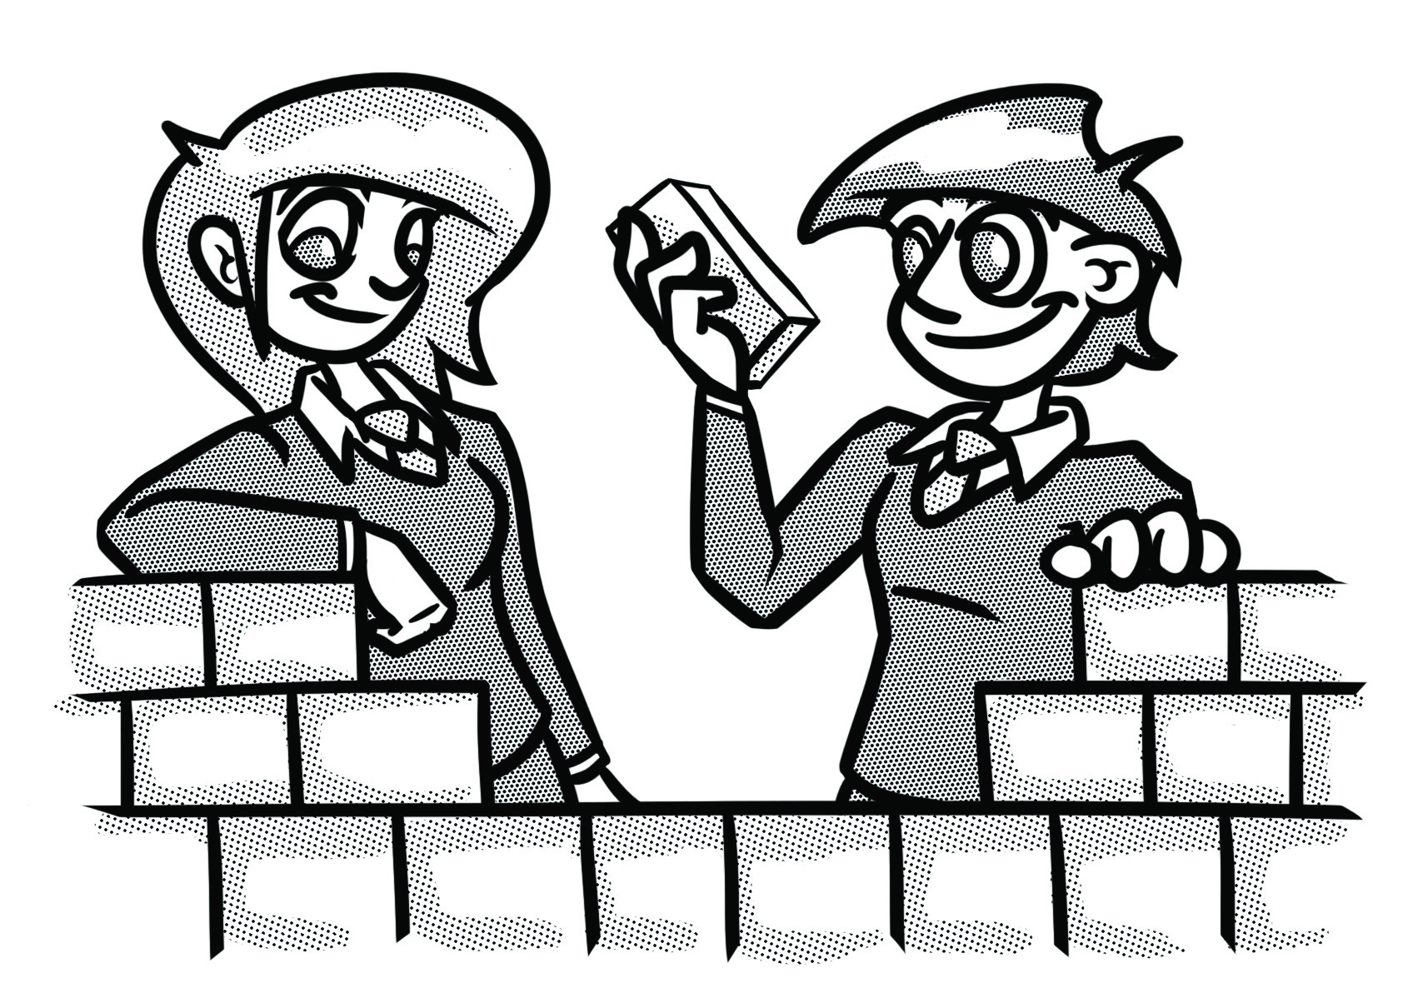

How to use this booklet:
- ‘Recapping the foundations’ offers support for some of the key foundational skills that will help you succeed. Read the sections you feel you need extra support with.
- Answer the questions in the brick walls on pages 8 and 9, starting at the bottom of each wall. You can refer to recapping the foundations to help, if you need to.
- When you have answered the question in a brick, colour it in red, amber or green depending on how confident you feel.

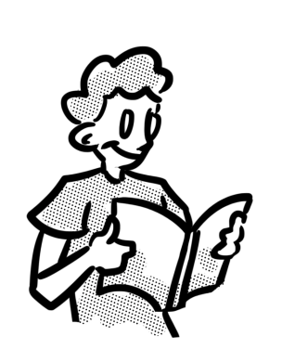
Recapping the foundations

Reading
Reading is the foundation for many of your subjects, not just English, but you will be expected to read a range of texts such as novels, poems and newspaper articles as part of your English lessons.

Here are some tips to help you get back into the habit of reading:
- Set a realistic reading goal. You could start by reading a paragraph a day, or a page a day. If you feel you can do more then do but, whatever you choose, make sure it’s manageable. You can increase the amount when you feel able to.
- Don’t break the chain! Once you’ve set a goal, make sure to keep on going – to be successful, we need to form habits by not skipping a day and not ‘breaking the chain’. Put a cross on a calendar every day that you maintain the habit.
- Start by reading different types of texts that you are interested in – these could be magazine articles, game reviews, articles about issues you’re interested in, fiction books on topics you like or autobiographies about people you are inspired by.
- Reading texts aloud can be useful when practising reading – try it and see how you can change your voice to show different characters speaking in different ways.

Writing
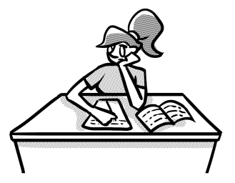
If you have not written much during lockdown, you will need to get back into the habit of doing so – not just for English, but other subjects as well. If possible, write by hand. However, you could discuss this with your teacher; they may feel working on a computer is best to get started.

To help you get back into the habit of writing by hand, try the tips below:
- Set yourself a writing goal and be realistic. If you haven’t written much during lockdown, you may want to start by writing bullet points about topics you’re interested in, or creating a paragraph a day and then work your way up slowly. Whatever you choose, make sure it’s manageable. You can increase the amount when you feel able to.
- Don’t break the chain! Once you’ve set a goal, make sure to keep on going – to be successful, we need to form habits by not skipping a day and not ‘breaking the chain’. Put a cross on a calendar every day that you maintain the habit.
- Start by writing about topics you are interested in – this could be about experiences you have had, issues that you feel strongly about, games or films you enjoy.

Writing for Purpose, Audience and Form
As well as being aware of the purpose, audience and form in texts you read, you need to be able to adapt your writing to suit different purposes, audiences and forms. But what do these words mean?

Purpose – why has the text been made? It could be to:
- inform the reader about something
- explain something
- advise on a particular issue
- persuade the reader to take action.

Audience – who will read, hear or see the text?
Although some texts are just read, others are heard (speeches) and some are performed and seen on stage or in films (scripts).

Form – what type of text is it?
There are a range of forms you will come across in the subjects you study. Some include:
- Newspaper or magazine articles
- Novels
- Poems
- Speeches
- Scripts

Read these mini examples and consider how each adapts the same topic for different forms.
Letter  Dear Detective Inspector Hound,  On August 15th 2017, an incident occurred on Forest Walk in The Woods which I feel requires your attention.  On August 15th, I was shocked to reach my grandmother’s house to find that Mr Wolf had entered her home in disguise.  …  Following your investigation, I would appreciate a meeting with you to discuss your findings and the way you plan to deal with this issue.  Kind regards,  Little Red Riding Hood | Informative text  How should you deal with an intruder?  - As soon as you hear the intruder enter, move to a different area of your house.  - Dial 444 and then press 3 to file a call to the Forest Police Department.  - Remain quiet and do not say anything.  - Listen and note any movements or noises, ready to report to the police when they arrive.
Advert  Forest Walk  Are you in need of a relaxing get away?  Are you tired of the busy, noisy life in the city?  Then Forest Walk is the place for you!  Picture the scene – a glistening lake, shielded from the sun by gorgeous green willow trees. You will be free to enjoy the scenic walks in our woodlands in complete safety, surrounded by natural beauty. | Speech  Imagine a world where vulnerable people are kept safe, where there’s someone always on hand to support, where no harm comes to them and they can live out their days happily.  This is what we’ve created at Forest Homes; we’re here today to invite you to invest in this new venture.

Sentences
A piece of writing is normally much more engaging and effective if it is written using varied sentences. The table below provides definitions for three sentence types and examples:
Sentence type | Definition | Example sentence
Simple sentence | A simple sentence is an independent clause with a subject and a verb. | Noah sprinted down the road.
Compound sentence | A compound sentence is a sentence with two independent clauses. | Noah sprinted down the road, but the dog ran away.
Complex sentence | A complex sentence is a sentence with one or more dependent clauses. | Although Noah sprinted down the road, the dog ran away.

It’s also a good idea to vary how you start your sentences. A paragraph that has sentences all starting with ‘you’ or ‘it’ can seem repetitive and a bit dull! There are many ways you could vary your sentences, but to help, you could try starting sentences with:
- A verb. For example: Breathing rapidly, she finally crossed the finish line.
- The word ‘as’. For example: As she crossed the line, she threw her arms in the air.
- A preposition. For example: After the race, the team went out to celebrate.
- An adverb. For example: Quickly, her coach ran to greet her.

Paragraphs
When we write in full sentences and create a long piece of text, it’s important that we break it up into paragraphs. To help you remember when to start using a new paragraph, you could think about the acronym TiP ToP:
a new topic
a change in time

TiP ToP

a new person speaks
a change in place

For example:
“A merry Christmas, uncle! God save you!” cried a cheerful voice. It was the voice of Scrooge’s nephew, who came upon him so quickly that this was the first intimation he had of his approach.

“Bah!” said Scrooge, “Humbug!”

He had so heated himself with rapid walking in the fog and frost, this nephew of Scrooge’s, that he was all in a glow; his face was ruddy and handsome; his eyes sparkled, and his breath smoked again.

Punctuation
Below is a table that explains when some of the commonly misused punctuation marks should be used and provides an example sentence for you to see it in use.

Punctuation | When should it be used? | Example sentence
Comma | The comma can be used to separate items in a list or to separate clauses (parts) of sentences. | To separate items in a list:  She purchased milk, flour, eggs and sugar from the shop so that she could make a cake.  To separate clauses:  Alex, the winner of the music competition, stood on the stage.
Apostrophe | The apostrophe can be used to show someone has possession of something or to show the omission of letters in a word.  Note: if you are referring to ‘it’ possessing something, you do not use an apostrophe. You would only use an apostrophe with ‘it’ to show omission (it’s a cold night). | Possession:  She put Stephanie’s bag into the boot of the car.  Omission:  He couldn’t believe his luck.
Ellipsis | An ellipsis can be used for several reasons:  - to replace missing text  - to allow a pause in writing to create suspense  - to highlight a change in thought from a character or the writer | As she reached the edge of the forest, she collapsed into a heap…
Speech marks | Speech marks can be used to show that a character is speaking.  Note: if a new character speaks, you need to use a new line. | “Come over here quickly, ” said mum. “I have something to show you.”  “What is it?” Richard asked.  “I’ll show you if you come here!”
Semi-colon | The semi-colon can be used to separate two main clauses in a sentence. | The bodywork sparkled and shone like a new car; David had spent hours polishing it.
Colon | The colon can be used to introduce a list, explanation or quotation. | Many people were late for school this morning: the traffic was awful.

Inference
To infer something means to draw a conclusion based on the evidence provided. We often refer to this as ‘reading between the lines’. For example, if you look at a traffic light showing red, what you actually see is the traffic light itself and the red light. You can infer that it would be dangerous to continue to walk, drive or cycle and that you should wait until it is safer before you cross the road.

Look at the picture below, for example. What do you think he is feeling and why?
You can use the questions around the picture to help you to draw possible inferences.
Why is he on his own?
Why is there a suitcase?
Why is he holding his phone but not looking at it?
Why is he holding his head in his hands?

To draw inferences from a text, we need to do exactly what you have done with this image – we need to dive deep into a text to explore the hidden clues and meanings which aren’t made explicitly obvious to us.

Homophones
Homophones are words that sound the same but have different meanings and spellings. There are many homophones, but some of the most misused ones are explained below:

There They’re Their  There refers to a place.  Over there is the playing field.  There is a shop near my house.  They’re is short for they are.  They’re really nice neighbours.  They’re going on holiday soon.  Their refers to something belonging to a group of people.  Their house is on Newton Lane.  Their dog is really playful. | Too To Two  Too means a lot or also.  Sylvia ate too much cake.  I’ve been to London too.  To is used with a verb or to give direction.  I am going to play in the match.  Our school is next to the playing field.  Two refers to the number 2.  It takes two people to play Snap!  There are two birds on the roof.
Its It’s  Its refers to something belonging to it.  The dog pulled on its lead.  The cat licked its paws.  It’s is short for it is.  It’s that time of year again.  It’s your responsibility to feed the dog. | Your You’re  Your refers to something belonging to you.  Your bag is over there.  Your house is around the corner.  You’re is short for you are.  You’re a pupil at this school.  You’re the future of our country!

Strengthening the foundations
When a builder builds a brick wall, they start with the foundations at the bottom. On the wall below, the activities at the bottom are easier and they become more difficult as you move up the wall and build on the foundations you started with.
- Start with the activities at the bottom and work your way up the wall.
- RAG-rate each brick you complete by colouring it in red, amber or green to represent how confident you felt about that task.
Read at least one chapter from a novel. Write three questions you would like to ask the author. |  | Read a fiction text from a genre that is new to you. Write a book review about it. |  | Write the opening to a formal letter arguing for exams, and then write an informal blog post arguing your own thoughts about examinations. |  | Redraft an article/speech you’ve written, varying sentences for effect. Experiment with using repetition from a sentence at the start in the ending.

Read at least one chapter of a biography or autobiography. Design an advert for the book or write a blog post about it. |  | Write a diary entry for a character in a book you have read, a film or a TV show. |  | Plan and write a speech persuading your chosen target audience to do more to save the planet. |  | Write the final 2-3 paragraphs of a blog post about a topic you feel strongly about. Vary your use of sentence structures.

Find a poem you like and practise reading it aloud – you could then perform it, either digitally or in person. |  | Write two pieces of creative writing based on the image in Task 3 (see page 10). In one, use the first person and in the second, use the third. |  | Choose a story, such as The Three Little Pigs, and recreate the content in the form of a newspaper article for adult readers. |  | Create a flash card with your own definitions of the three sentence structures (see page 5). Write your own examples for each one.
Read an article and summarise what you have read in five sentences. Then simplify this into just one sentence. |  | Write a diary for 14 days. On Day 1 write a sentence, on Day 2 write two sentences – until you’re writing fourteen sentences on Day 14. |  | Write a paragraph about your ability to cook that is conversational, light-hearted and amusing in tone. |  | Complete Task 1 (see page 10) by identifying whether the sentences in the table are simple, compound or complex.

Write a short story which begins with the words ‘No one ever saw it coming’. Use paragraphs of varying lengths. |  | Create the final 2-3 paragraphs of a chapter which will leave the reader in suspense. Use at least three different punctuation marks. |  | Choose two adverts for skin/hair care products. What is explicitly stated? What can be inferred from the language used? |  | Think of other homophones that have not been explored in this booklet. List as many as you can and create a guide on how to use them for a younger pupil.

Write a magazine article about a topic of your choice. Use paragraphs correctly. |  | Produce a short guide for Key Stage 3 students to explain how to use different punctuation marks. Make sure you give them example sentences. |  | Choose an article on a current issue. Annotate the heading and vocabulary/ phrases with the inferences you draw from them. |  | Make your own homophones quiz and swap with a friend to test each other.

Write the text for a blog post about your year so far. Use paragraphs correctly. |  | Write a 200-word short story entitled ‘What a disaster!’ Use at least three different types of punctuation marks. |  | Connotations are the ideas or feelings a word gives us. For example, the red traffic light connotes danger. What are the other connotations for red? What about white? |  | Create your own sentences based on the homophones covered in this booklet.

Create a poster for a classroom to show students how paragraphs should be used. |  | Complete Task 2 (see page 10) by rewriting the paragraph correctly with capital letters and a range of punctuation. |  | Complete Task 3 (see page 10) by annotating inferences around the image you have been given. |  | Complete Task 4 (see page 10) by selecting the correct homophones for the sentences. Refer back to page 7 if you need help.

Task 1: Sentences
Identify whether the sentences on the left are simple, compound or complex.
Sentence | Simple, compound or complex?
David drove to the basketball match.
The teacher, who had just started working at the school, was called Mr Jones.
Shauni, who had been stuck in traffic, picked her friend up over an hour late.
The weather was terrible in England, so they decided to go on holiday.
The bus was over half an hour late.
The cat pounced in the air and the bird flew away.
Alice drives a silver Corsa but Jim drives a red Ford.

Task 2: Punctuation
Correct/rewrite the paragraph below.

Suddenly she could hear mr rowley rummaging through the boxes what was he doing martha hoped he wouldn’t look inside the cupboard it was dark inside there were lots of weird looking parcels and it smelt really damp martha was sure that he would be leaving soon because he had to be in london by lunchtime suddenly she heard his footsteps getting closer to the cupboard he was trying to turn the handle she was terrified
Task 3: Inference
Annotate the image on the right with inferences you can make based on the details you see.

Alternatively, you could start by writing questions about it, like in the example on page 7 and then listing possible answers.

Task 4: Homophones
Insert the correct homophones into the sentences below.
- When you arrive ________ you will see the huge gates at the entrance.
- When you visit your friends, you should say thank you to _______ parents.
- _____________ so welcoming.
- _________ right James, _________ new rabbit is really cute!
- The train is on _____ way to London. _____ going really fast through the countryside.
- The dog played with _____ toy.
- ______ all your fault.
- “Would the _____ of you like ____ eat fish and chips for dinner?” Mum asked.
- _____ chocolate bars would be _____ much.

© Commissioned by The PiXL Club Ltd. July 2020

This resource is strictly for use by The PiXL Club Ltd member schools during the life of the membership only. It may NOT be copied, sold, or transferred or made available by whatever means to a third-party non-member during or after membership. Until such time it may be freely used within the PiXL member school by their teachers and authorized staff and any other use or sale thereof is strictly prohibited.

All opinions and contributions are those of the authors. The contents of this resource are not connected with, or endorsed by, any other company, organisation or institution.

PiXL Club Ltd endeavour to trace and contact copyright owners. If there are any inadvertent omissions or errors in the acknowledgements or usage, this is unintended and PiXL will remedy these on written notification.

