Strengthening the Foundations Workbook
KS4 Higher Maths

Hello!

Even in the best of times, not everything goes to plan. Things happen – things we cannot control - which affect our learning. It is nothing to worry about. We all have strengths and weaknesses; we all have to work hard to achieve our goals. Remember, your teachers know what you are good at and they know what you find difficult. They will support you.

In all subjects you learn at school, or college, there are important concepts and ideas which help you to understand a topic and provide the foundations for future learning. If you don’t have solid foundations, the rest of your knowledge will be unstable and not as secure as it could otherwise be.

The purpose of this workbook is to make sure your foundations are stable so that you can build the rest of your learning on it and have the strongest bank of knowledge and skills as possible.

Creating a stable foundation takes regular practice. We hope that this booklet will help you on your journey.

So, let’s practise!

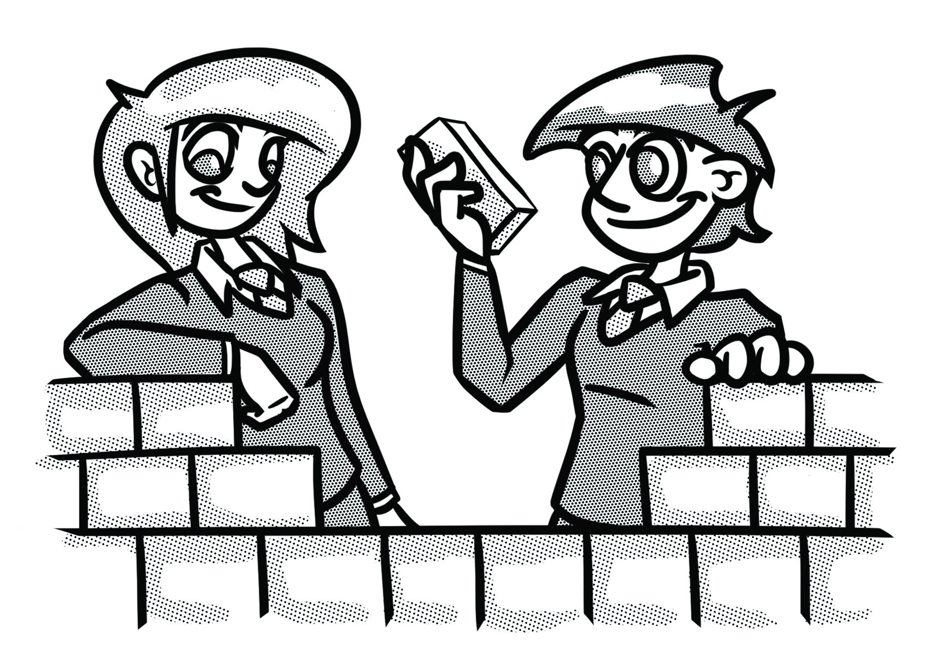

How to use this booklet
- Read the ‘recapping the foundations’ section of the booklet (see below). You can refer to this when you answer the questions.
- Answer the questions in the brick walls on pages 5 and 6 - start at the bottom of each wall.
- When you have answered the question in a brick, colour it in red, amber or green depending how confident you feel.

Recapping the foundations

Solving simultaneous equations

Both linear
Label the equations. Multiply one or both equations to make the coefficients of $x$ or $y$ the same. Then decide if you need to add or subtract the equations.

One linear, one quadratic.
$$x+3y=10$$
$$x^{2}+y^{2}=20$$
Rearrange the linear, and substitute into the quadratic $x=10-3y$
$$so (10-3y)^{2}+y^{2}=20$$
Expand and solve the quadratic $100-60y+9y^{2}+y^{2}=20$
$10y^{2}-60y+80=$𝟎
Factorise or solve
$$y=2 or y=4$$
Finally, substitute into the linear equation and solve - pairing values…
$$x+3×2=10 so (x ,y) = (4 , 2)$$
$$x+3×4=10 so (x ,y) = (-2 , 4)$$

Solving quadratics
Factorising.

$$x^{2}-8x+15=0$$
Put it into brackets, taking care with any negative numbers.
$$(x-3)(x-5)=0$$
So, either… $x-3=0 or x-5=0 so that x=3 or x=5.$

Changing the subject

The subject of a formula is the term on its own.

Make 𝒙 the subject of: $2x+ 3y=z$
Subtract 3𝑦 from both sides: $2x=z-3y$
Then divide both sides by 2: $x=\frac{z-3y}{2}$

Ratio in context

For any ratio question, always start by underlining the key words. Then, find the instruction - what is the question asking you to do? Next draw a diagram. This might be a bar model or a table to help you. Finally, make sure your solution is clear. This is KIDS Rules!

Beth has 600 counters.
$\frac{3}{5}$ of the counters are yellow.
75% of the remainder are red.
The rest of the counters are green.
Beth is given some more red counters.
Now the ratio of the number of green counters to the number of red counters is 1:4.
How many red counters was Beth given?

Once you have identified the key information and the instruction, draw this as a bar model.
Step 4: Once you have the bar model, you can now answer the question.
There are 60 extra counters.
Red
Yellow
60
60
60
60
60
Step 1: The whole bar is representing 600 counters so we know each box is 600$÷$5= 120
Step 3: Draw boxes to show the new ratio with the values
Step 2: Yellow is 3 boxes (360) and then red is 75% of what is left (180). The remainder is green (60)
120
120
120
120
120

Strengthening the foundations
When a builder builds a brick wall, they start with the foundations at the bottom. On the wall below, the activities at the bottom are easier and they become more difficult as you move up the wall and build on the foundations you started with.
- Start with the activities at the bottom and work your way up the wall.
- RAG-rate each brick you complete by colouring it in red, amber or green to represent how confident you felt about that task.

Write a question for the diagram in ‘Question 1’ on page 7. |  | Using the information in ‘Question 2’ on page 7, write a question and mark scheme. |  | Bobbi is 3 years older than Sue. Their ages added together equal 51. Calculate Sue’s age. |  | Find the value of the two distinct numbers $x$ and $y$, if:  - $x$ is two less than $y$  - $y$ is equal to the square of $x$

Write a question with the answer:  $$x=5, y=3$$ |  | Solve simultaneously:  $$3x+20=y+3 \\ 2x-4=2y-22$$ |  | Solve simultaneously:  $$x^{2}=y$$  $$x=y-2$$ |  | A rectangle has a perimeter of 32cm. Its length is 4cm longer than its width. What is its width?

Make $x$ the subject:  $$x-6=\frac{3+x}{y}$$ |  | Solve simultaneously:  $$2x+y=33 \\ 3x-y=27$$ |  | Write a revision page for solving quadratics, including all key points, and give two examples. |  | Write a list of instructions for solving the simultaneous equations below.
Make $x$ the subject:  $$3x-4=7y$$ |  | Expand:  $$(4-x)(x+5)$$ |  | Solve:  $$x^{2}+12x+7=0$$ |  | Solve simultaneously:  $$3x-5=y \\ x+y=7$$

At a concert the ratio of adult men to adult women is 6 : 5. The ratio of adult women to children is 7 : 3. Show that less than half of the people at the concert are men. |  | Complete  ‘Question 3’ on page 8. |  | Use ratio to write a question for the diagram shown in ‘Question 4’ on page 8. |  | Using the following information, write a question and mark scheme:  In a gym, the ratio of men to women is 2 : 3. 50% of the men are under 30, and $\frac{1}{3}$ of the women are under 30.

Make a scale drawing of a room in your house, include the area of the walls and calculate the volume. |  | Write a revision page on solving ratio problems in context, what are the key points to remember? |  | The points A, B, C and D lie in order on a straight line such that:  AB : BD = 4 : 3  AC : CD = 3 : 11  Find A:B:C:D |  | The ratio of men to women is  5 : 3. 30% of the men are under 25, and 20% of the women are under 25. What percentage of all the people in the office are under 25?

Joe makes a model of a house. The measurements of the actual house are ten times bigger than the measurements of the model. What is the scale of his model? |  | $$5 miles≈8 kilometres$$  Use the information above to decide who has travelled furthest:  Uzma ran 8 miles.  Janet ran 10 kilometres. |  | It takes 12 people 6 hours to chop down the trees in the field. How long would it take 18 people? |  | 1 foot = 12 inches.  Andy is 74inches tall. How tall is Andy in feet and inches?

There are some sweets in a box. $\frac{2}{7}$ of the sweets are toffee and the rest are chocolate.  Write the ratio in the form 1:n. |  | Tom and Harry share a box of chocolates in the ratio 2:3.  What fraction of the chocolates does Tom have? |  | Ella, Lucy and Daisy share some sweets in the ratio  3 : 4 : 9.  Daisy gets 24 more sweets than Ella.  How many sweets does each person get? |  | Share £200 in the ratio  1: 2 : 5.

Questions

Question 1.

Using the diagram below, write a question and a mark scheme.

$$x$$
$$x$$
$$y$$
2$x$
$$3y$$

Perimeter = 11 cm Perimeter = 21 cm

Question 2.

Using the information in the diagram, write a question and mark scheme.

Receipt:
4 x adult
2 x child
Total: £64
Receipt:
3 x adult
4 x child
Total: £65.50

Question 3.
In maths it is crucial that we have a method for checking our answers. This might be working backwards or undoing what you have already done.

All four questions below have the answer 40. Can you find a way to fill in the gaps?

A shade of green paint is to be made by mixing yellow, blue and white paint using the ratio 5:3:1.
The paint uses ___ml of blue. How much white is to be used?

Karen and Mary share £115.50. Mary receives ___% more than Karen. How much did Karen receive?

The ratio of cats to dogs in a kennel is 2:5. There are ___ more dogs than cats. Work out how many dogs there are.

A recipe for cakes needs sugar, flour and butter. The ratio of sugar to butter is 2:5. The recipe uses __ times as much flour as sugar. A cake weighs 480 g. Calculate how much sugar is needed.
The answer is 40

Question 4.
Write a question involving ratio based on the diagram below. You need to include a mark scheme.
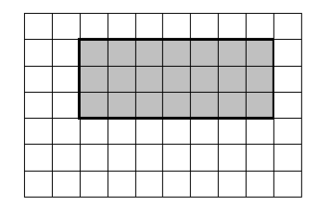

© Commissioned by The PiXL Club Ltd. July 2020

This resource is strictly for the use by The PiXL Club Ltd member schools during the life of the membership only. It may NOT be copied, sold, or transferred or made available by whatever means to a third-party non-member during or after membership. Until such time it may be freely used within the PiXL member school by their teachers and authorized staff and any other use or sale thereof is strictly prohibited.

All opinions and contributions are those of the authors. The contents of this resource are not connected with, or endorsed by, any other company, organisation or institution.

PiXL Club Ltd endeavour to trace and contact copyright owners. If there are any inadvertent omissions or errors in the acknowledgements or usage, this is unintended and PiXL will remedy these on written notification.

