Strengthening the
Foundations Workbook
KS4 English Language

Students would benefit from having a range of unseen extracts and a novel.

Hello!

Even in the best of times, not everything goes to plan. Things happen – things we cannot control – which affect our learning. It is nothing to worry about. We all have strengths and weaknesses; we all have to work hard to achieve our goals. Remember, your teachers know what you are good at and they know what you find difficult. They will support you.

In all subjects you learn at school, or college, there are important concepts and ideas which help you to understand a topic and provide the foundations for future learning. If you don’t have solid foundations, the rest of your knowledge will be unstable and not as secure as it could otherwise be.

The purpose of this workbook is to make sure your foundations are stable so that you can build the rest of your learning on it and have the strongest bank of knowledge and skills as possible.

Creating a stable foundation takes regular practice. We hope that this booklet will help you on your journey.

So, let’s practise!
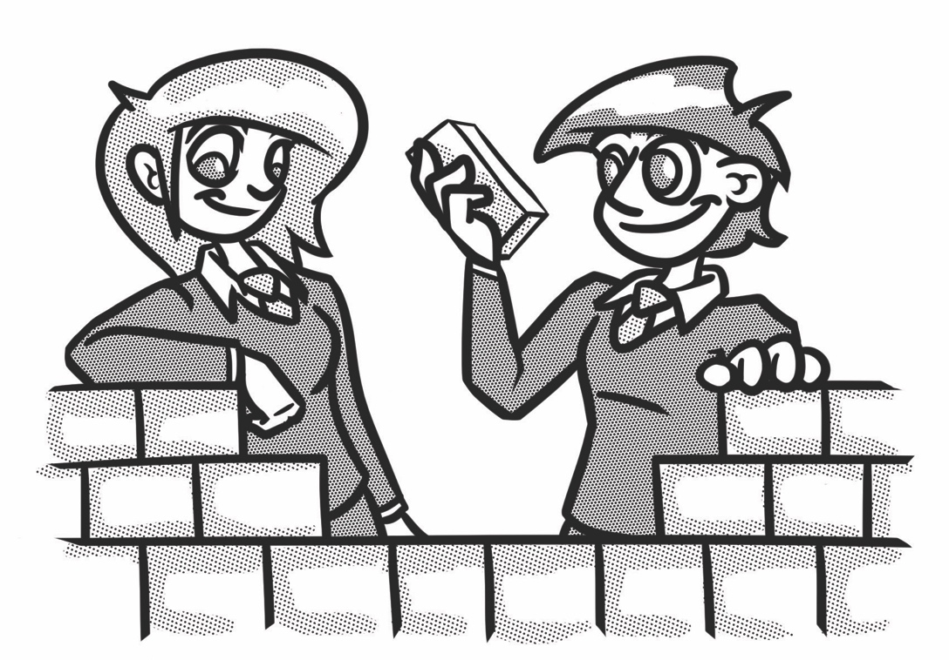

How to use this booklet:
- ‘Recapping the foundations’ offers support for some of the key foundational skills that will help you succeed. Read the sections you feel you need extra support on.
- Answer the questions in the brick walls on pages 7 and 8, start at the bottom of each wall. You can refer to recapping the foundations to help, if you need to.
- When you have answered the question in a brick, colour in red, amber or green depending how confident you feel.

Recapping the foundations

Reading a range of texts
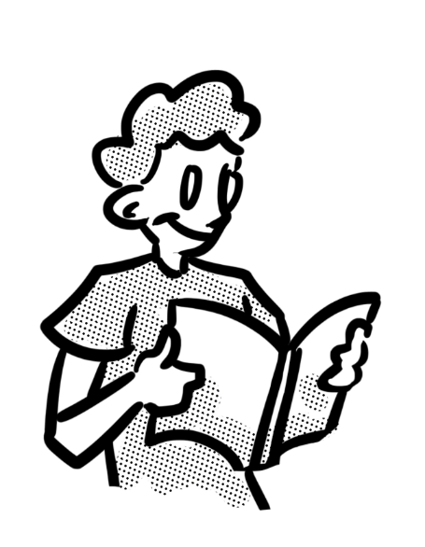
For your English Language GCSE exam, you will read fiction and non-fiction extracts from the 19th, 20th and 21st centuries. You will therefore need to have read a wide range of these to ensure that you are as prepared as possible for the unseen examination extracts.

If this is something you need to work on, read the tips below to help you get back into the habit of reading:

- Set yourself a reading goal and start by being realistic. If you haven’t read very much recently, you may want to start by reading a paragraph a day, or a page a day. If you feel you can do more then do but, whatever you choose, make sure it’s manageable. You can, and indeed should, increase the amount when you feel able to.
- Don’t break the chain! Once you’ve set a goal, make sure to keep on going – to be successful, we need to form habits by not skipping a day and not ‘breaking the chain’. Put a cross on a calendar every day that you maintain the habit.
- Start by reading texts that you are interested in – these could be magazine articles, game reviews, articles about issues you’re interested in, fiction books on topics you like or autobiographies about people you are inspired by.

You will probably be more experienced with modern texts so, once you are back in the habit of reading, you may wish to explore a range of 19th century fiction and non-fiction to become more familiar with the sentence structures and vocabulary used. You can access free copies of many 19th century novels online or through apps on your device, as well as being able to borrow them from libraries. Your school may also be able to provide you with extracts.

Inference
To infer something means to draw a conclusion based on the evidence provided. We often refer to this as ‘reading between the lines’. For example, if you look at a traffic light showing red, what you actually see is the traffic light itself and the red light. You can infer that it would be dangerous to continue to walk, drive or cycle and that you should wait until it is safer before you cross the road.

Look at the picture below, for example. What do you think he is feeling and why?
You can use the questions around the picture to help you to draw possible inferences.
Why is he on his own?
Why is there a suitcase?
Why is he holding his phone but not looking at it?
Why is he holding his head in his hands?

To draw inferences from a text, we need to do exactly what you have done with this image – we need to dive deep into a text to explore the hidden clues and meanings which aren’t made explicitly obvious to us.

Writing for Purpose, Audience and Form
As well as being aware of the purpose, audience and form in texts you read, you need to be able to adapt your writing to suit different purposes, audiences and forms. Common purposes include: to inform, explain, advise, argue and persuade.

Most students tend to be confident with how to write for different purposes and audiences. However, writing in the correct form can be an issue in the non-fiction writing part of the exam. To start, it’s important to read the question being asked to check you’ve not mis-read it, so that you don’t write a formal letter instead of an informal blog post, for example. It’s also important to revise the features of forms fully, such as how to lay out a letter or when to include headings or subheadings.

Read these mini examples and consider how each adapts the same topic for different forms.
Dear Detective Inspector Hound,  On August 15th 2017, an incident occurred on Forest Walk in The Woods which I feel requires your attention.  On August 15th, I was appalled to reach my grandmother’s house to find that Mr Wolf had entered her home under a fraudulent disguise.  …  Following your investigation, I would appreciate a meeting with you to discuss your findings and the way forward you plan to take to address this issue.  Kind regards,  Little Red Riding Hood | How should you deal with an intruder?  - As soon as you hear the intruder enter, move to a different area of your house.  - Dial 444 and then press 3 to file a call to the Forest Police Department.  - Remain quiet and do not say anything.  - Listen and note any movements or noises, ready to report to the police when they arrive.
Forest Walk  Are you in need of a relaxing get away?  Are you tired of the busy, noisy life in the city?  Then Forest Walk is the place for you!  Picture the scene – a glistening lake, shielded from the sun by gorgeous green willow trees. You will be free to enjoy the scenic walks in our woodlands in complete safety, surrounded by natural beauty. | Imagine a world where vulnerable people are kept safe, where there’s someone always on hand to support, where no harm comes to them and they can live out their days happily.  This is what we’ve created at Forest Homes; we’re here today to invite you to invest in this new venture.

Planning
Planning is a really important skill. This is the foundation for all of your extended written responses, as well as for the spoken elements of the GCSE. Spending time planning means you are more likely to identify relevant ideas in response to the question, organise them in a clear way and present them effectively.

There are many ways you can plan (bullet points, spider diagrams, Venn diagrams etc.) but essentially, when you plan, you need to do the following:
- Identify points and quotations that respond to the exact question you’ve been asked
- Order these points into a clear and logical structure
- Decide how you will present these ideas – consider what methods you will use and how you will start and end your writing to suit the purpose, audience and form.

Vocabulary
Knowledge of vocabulary is key to helping you to understand what you read, as well as being able to write effectively to a given brief. Most students know that they are expected to use a wide range of ambitious vocabulary, but not many know how to achieve this.

To help develop our vocabulary, we can learn new words from texts we have read and by using a thesaurus. At GCSE, it is a good idea to use vocabulary in a targeted way. Rather than always adding descriptive words, you can improve the verbs or nouns you use. For example, instead of saying ‘he walked quickly’, you could say ‘he tore down the street’.

Punctuation
The GCSE examiner reports often identify the use of punctuation as being an area that students are not as confident with as they could be.
Below is a table that explains when some of the commonly misused punctuation marks should be used and provides an example sentence for you to see it in use. Revise these before moving on to the next section of the booklet.

Punctuation | When should it be used? | Example sentence
Comma | The comma can be used to separate items in a list or to separate clauses (parts) of sentences. | To separate items in a list:  She purchased milk, flour, eggs and sugar from the shop so that she could make a cake.  To separate clauses:  Alex, the winner of the music competition, stood on the stage.
Apostrophe | The apostrophe can be used to show someone has possession of something or to show the omission of letters in a word.  Note: if you are referring to ‘it’ possessing something, you do not use an apostrophe. You would only use an apostrophe with it to show omission (it’s a cold night). | Possession:  She put Stephanie’s bag into the boot of the car.  Omission:  He couldn’t believe his luck.

Semi-colon | The semi-colon can be used to separate two main clauses in a sentence. | The bodywork sparkled and shone like a new car; David had spent hours polishing it.
Colon | The colon can be used to introduce a list, explanation or quotation. | Many people were late for school this morning: the traffic was awful.

Sentences
A piece of writing is normally much more engaging and effective if it is written using varied sentences. At GCSE, you may wish to comment on the sentence styles a writer has used, but you also need to be mindful of using varied sentences in your own writing.

The table below provides definitions for three sentence types, as well as examples of these.

Sentence type | Definition | Example sentence
Simple sentence | A simple sentence is an independent clause with a subject and a verb. | Noah sprinted down the road.
Compound sentence | A compound sentence is a sentence with two independent clauses. | Noah sprinted down the road, but the dog ran away.
Complex sentence | A complex sentence is a sentence with one or more dependent clauses. | Although Noah sprinted down the road, the dog ran away.

Writing at length
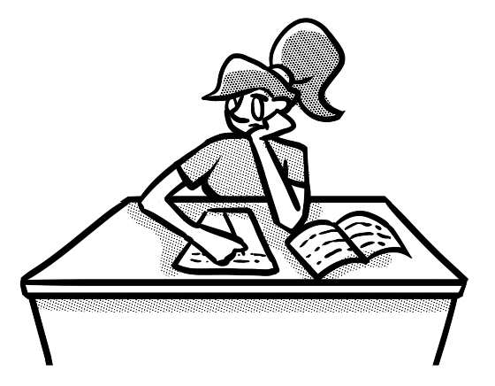
Being able to write at length is obviously fundamental to you achieving well in English; you will have to write responses to reading questions, such as when you analyse an extract, as well as to create your own piece of fiction or non-fiction writing.

If you have not written by hand during lockdown, or written very little, you will need to get back into the habit of doing so – not just for English, but other subjects as well. Unless you have an Access Arrangement, you will be completing your exams by hand and so this will be key to your success.

To help you get back into the habit of writing by hand, you could try the tips below:
- Set yourself a writing goal and be realistic. If you haven’t written much during lockdown, you may want to start by writing bullet points about topics you’re interested in, or creating a paragraph a day and then work your way up slowly to producing a whole page each day. Whatever you choose, make sure it’s manageable. You can increase the amount when you feel able to.
- Don’t break the chain! Once you’ve set a goal, make sure to keep on going – to be successful, we need to form habits by not skipping a day and not ‘breaking the chain’. Put a cross on a calendar every day that you maintain the habit.
- Start by writing about topics you are interested in – this could be about experiences you have had, issues that you feel strongly about, games or films you enjoy.

Strengthening the foundations
When a builder builds a brick wall, they start with the foundations at the bottom. On the wall below, the activities at the bottom are easier and they become more difficult as you move up the wall and build on the foundations you started with.
- Start with the activities at the bottom and work your way up the wall.
- RAG-rate each brick you complete by colouring it in red, amber or green to represent how confident you felt about that task.

Read the opening chapter to a novel; make a list of what the reader finds out. Predict what might happen next. |  | Read the extract from Task 1 (see page 9) and respond fully to the second activity, using your inference skills. |  | Plan and write a speech persuading your chosen target audience to do more to save the planet. |  | After completing Task 4, write a commentary about why you used the methods and structure you did.

Read an article with a clear viewpoint on a topic. Make notes on the points covered and then present the structure in a flow chart. |  | Choose two adverts for skin/hair care products. What is explicitly stated? What can be inferred from the language used? |  | Write a guide for over 65-year olds to encourage them to use technology. Choose vocabulary carefully so that the text is accessible. |  | Create a plan for a letter to either your headteacher or local councillor, asking for more facilities for students.

Read an article/speech of your choice and summarise it in six sentences. Then condense this further into just one sentence. |  | Choose an article on a current issue. Annotate the heading and vocabulary/ phrases with the inferences you draw from them. |  | Choose a story, such as The Three Little Pigs, and recreate the content in the form of a newspaper article for adult readers. |  | Create a plan for a story inspired by a character you’ve seen/read about. As well as what will happen, identify methods you’ll use.
Read the extract from Task 1 (see page 9) and respond to the first activity by identifying five experiences the group encountered. |  | Connotations are the ideas or feelings a word gives us. For example, the red traffic light connotes danger. What are the other connotations for red? What about white? |  | Create a table to document methods and key features for each non-fiction form that you might be asked to write in: letter, speech, blog post, article etc. |  | Imagine you’ll be writing an informative guide to your school for a Year 6 pupil. Identify key points they’ll need to know and then order these into a plan.

Using a new image that you haven’t responded to before, create a description using carefully chosen words and phrases. |  | ‘The arts are not important.’ Write an article explaining your viewpoint on this topic. Vary your punctuation and include a rhetorical question as well as a list of three. |  | Redraft an article/speech you’ve written, varying sentences for effect. Experiment with using repetition from a sentence at the start in the ending. |  | Write a response to one of the tasks in Task 4 (see page 10), using the success criteria you’ve been given. Before you start, make sure you plan your response.

Choose an image (photograph, artwork or picture from an article or book) and select 20 words or phrases that could be used to describe it. |  | Create the final 2-3 paragraphs of a chapter which will leave the reader in suspense. Use at least three different punctuation marks. |  | Write the final 2-3 paragraphs of a blog post about a topic you feel strongly about. Vary your use of sentence structures for effect. |  | Write the opening to a formal letter arguing for rigorous exams, and then write an informal blog post arguing your own thoughts about examinations.

Read a non-fiction article and/or a page from a fiction book. Identify at least five words that you don’t know and find out the meaning. Use each one in a sentence. |  | Describe a memory you have of an event by writing at least one paragraph. Within this, use at least five different punctuation marks. |  | Create a flash card with your own definitions of the three sentence structures (see page 6). Write your own examples for each one. |  | Write the opening to a short story which begins with the words ‘No one ever saw it coming’.

Complete Task 3 (see page 10) and then find at least five alternative words or phrases for each of the following words: sad, happy, confused, spoke, old. |  | Produce a short guide for Key Stage 3 students to explain how to use different punctuation marks. Make sure you give them example sentences. |  | Complete Task 2 (see page 9) by identifying which sentences are simple, compound or complex. |  | Write a paragraph about your ability to cook that is deliberately conversational, light-hearted and humorous in tone.

Task 1: Reading a range of texts and practising inference
Read the following extract and answer the questions below.

So strange an accident has happened to us that I cannot forbear recording it, although it is very probable that you will see me before these papers can come into your possession.
Last Monday (July 31st) we were nearly surrounded by ice, which closed in the ship on all sides, scarcely leaving her the sea-room in which she floated. Our situation was somewhat dangerous, especially as we were compassed round by a very thick fog. We accordingly lay to, hoping that some change would take place in the atmosphere and weather.
About two o’clock the mist cleared away, and we beheld, stretched out in every direction, vast and irregular plains of ice, which seemed to have no end. Some of my comrades groaned, and my own mind began to grow watchful with anxious thoughts, when a strange sight suddenly attracted our attention and diverted our solicitude from our own situation. We perceived a low carriage, fixed on a sledge and drawn by dogs, pass on towards the north, at the distance of half a mile; a being which had the shape of a man, but apparently of gigantic stature, sat in the sledge and guided the dogs. We watched the rapid progress of the traveller with our telescopes until he was lost among the distant inequalities of the ice.
Letter 4 from Frankenstein, Mary Shelley

- Identify five experiences the group encountered on July 31st.
- How did members of the group feel before the ‘strange sight’ appeared? How did they feel after they had seen it? Use quotations to support your response.

Task 2: Sentences
Identify whether the sentences on the left are simple, compound or complex.

Sentence | Simple, compound or complex?
David drove to the basketball match.
The teacher, who had just started working at the school, was called Mr Jones.
Shauni, who had been stuck in traffic, picked her friend up over an hour late.
The weather was terrible in England, so they decided to go on holiday.
The bus was over half an hour late.
The cat pounced in the air and the bird flew away.
Alice drives a silver Corsa but Jim drives a red Ford.

Task 3: Vocabulary
Sometimes when you look up a word in a thesaurus, synonyms (words that are the same or similar in meaning) will appear that would not suit all contexts due to their connotations and inferred levels of intensity, for example.

Below, you have been given two words and several synonyms for each. Think carefully about the intensity levels of these and plot them on the dial to show how they change in intensity. The synonym for walk which has the lowest level of intensity has been plotted on the dial to get you started.

- Synonyms of walk: dawdle, strut, stroll, march, scramble, crawl
- Synonyms of worried: nervous, agitated, on-edge, distressed, fretful, uneasy
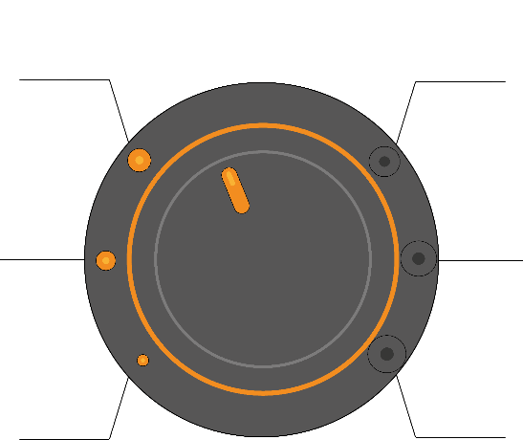
crawl

Task 4: Planning and writing at length
Respond to one, or both, of the tasks below.

You should remember to:
- Plan your work to consider what you will write, how you will structure it and what methods you may like to use
- Vary sentence structures
- Use interesting vocabulary
- Use paragraphs.

- Create a fiction or non-fiction extract, inspired by the picture below.

- Create a piece of writing which starts with: Before they knew it, it was gone.

© Commissioned by The PiXL Club Ltd. July 2020

This resource is strictly for the use by The PiXL Club Ltd member schools during the life of the membership only. It may NOT be copied, sold, or transferred or made available by whatever means to a third-party non-member during or after membership. Until such time it may be freely used within the PiXL member school by their teachers and authorized staff and any other use or sale thereof is strictly prohibited.

All opinions and contributions are those of the authors. The contents of this resource are not connected with, or endorsed by, any other company, organisation or institution.

PiXL Club Ltd endeavour to trace and contact copyright owners. If there are any inadvertent omissions or errors in the acknowledgements or usage, this is unintended and PiXL will remedy these on written notification.

