There is a wide range of resources and events which are being advertised to support students with their decisions around their next transition stage. Take a look at the links below to find out more.
Barclays LifeSkills
Build your skills wheel! A matching activity to see which careers suit your personality, skills and interests. Takes about 5 minutes to do and then as long as you want to explore your career ideas.
Wheel of Strengths | What job suits me | Barclays (barclayslifeskills.com)
Take a look at the link below for some support in creating your CV. There are some excellent templates and support resources as well as a video lesson in how to create!
CV Writing Lesson Plan | Barclays LifeSkills
Have a look at the link below for a range of different case study videos – there is a range of different industries covered in these videos and they all feature young people working in those roles.
Exploring job sectors and preparing for work | LifeSkills (barclayslifeskills.com)

Army Careers
Army Careers Presentation Films 1 - 2 on Vimeo
On the 5th March at 11.30 the Army will be hosting a live webinar. They will provide a whistle stop tour of Army Careers to celebrate National Careers Week. This virtual event is for students and teachers interested in finding out more about Army opportunities; no previous knowledge required. We’ll also be looking at the qualifications on offer including apprenticeships and degrees, as well as the Army Foundation College, Harrogate.
To register your interest, click on the link below
National Careers Week – Insight into Army Careers virtual event - 5th March (adobeconnect.com)

Staffordshire University - Your Future in Health and Social Care - 4 March at 9:30am
Experience the patient journey at Staffordshire University by joining our event and taking part in the following sessions led by our School of Health and Social Care academics:
• Paramedics
• Operating Department Practice
• Midwifery
• Children's Nursing
• Adult Nursing
• Mental Health Nursing
• Social Work
• Health and Social Care
To book yourself on to the event click on the link: Your Future in Health and Social Care Tickets, Thu 4 Mar 2021 at 09:30 | Eventbrite
Information for parents

We have shared two parent information booklets on our school website which can be accessed on the following link: Information for Parents

In addition to this is a free parent’s workshop which we would like to share with you – to register click on the link below.

The Power of Networks, Wednesday 3rd March, 7-8pm (GMT)
Expert advice on how your child can build a powerful network, led by Heather White, CEO and founder of Smarter Networking.
Webinar Registration - Zoom

NHS Careers - Live Events
All the links are in blue font below:
At 10am on Wednesday, Thursday and Friday (3, 4 and 5 March), the NHS will be hosting a series of Facebook Live events which will cover routes into an NHS career, all things nursing, apprenticeships and more. There’ll be plenty of time to ask questions too, so see you there!
Careers quizzes
Our online quizzes are an invaluable way to get personalised NHS career ideas in just a few minutes! Give them a try:
- NHS Health Careers quiz
- Step into the NHS careers quiz
Key stage 4 resources
The Step into the NHS online tools and resources for Key stage 4 students are ideal for preparing students for the world of work.
Work experience
We know that getting work experience is particularly tricky at the moment, so you may find our work experience guide and work experience ideas helpful.

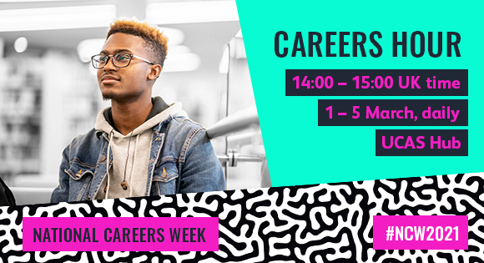

What’s on…
Monday 1 March  Student stories: Uni or apprenticeship? | Hear from students and apprentices on what it’s actually like, either studying at uni or in the workplace. Find out how they decided on their path, how it’s different to school or college, and most importantly… ask questions!
Tuesday 2 March  CV writing workshop with Reed | Knowing what to include, the language to use, and how to structure your CV is something you’ll use for your entire working life. In this workshop, recruitment experts from Reed take you through all this and more. Ask questions, make notes and get involved.
Wednesday 3 March  Jack Parsons: Becoming an award-winning CEO in his early 20s | Jack became CEO of The Youth Group in 2018. His career kicked off by taking a photo of two coffee cups. He’s now known as the UK’s Chief Youth Officer and has been named as the Most Connected Young Entrepreneur. In this session Jack takes us through his journey as a self-starter, sharing the challenges he’s had to overcome, and offering you advice as you research your options. He’ll also be taking some of your questions, live!
Thursday 4 March  How to secure a school-leaver opportunity | Discover some of the very best school-leaver opportunities available to apply for right now at some of the biggest companies in the UK and beyond. We’ll hear from young people working in the companies, how they successfully got the job, what they do now and what their future holds. Join us for this highly informative and practical session where you’ll get hints and tips on how to apply for their opportunities and how to ace their recruitment processes.
Friday 5 March  How to ace interviews | Interviews are as much of a science as they are an art. In this workshop, recruitment expert, Hayley shares the secrets to acing your interview. From how to prepare, tips for questions you’ve not prepared for and more… It’s a session not to miss!
How to register
Register for a UCAS Hub account. We’ll be streaming live everyday there. Hit the top banner to watch, ask questions, and tell us what you think!
Already got a UCAS Hub account? GREAT! Sign in at 14:00 (UK time) hit the top banner and you’re there! Sign in | UCAS

