Strengthening the Foundations Workbook
KS4 Physics
Students will need a copy of the examination board equations

Hello!

Even in the best of times, not everything goes to plan. Things happen – things we cannot control - which affect our learning. It is nothing to worry about. We all have strengths and weaknesses; we all have to work hard to achieve our goals. Remember, your teachers know what you are good at and they know what you find difficult. They will support you.

In all subjects you learn at school, or college, there are important concepts and ideas which help you to understand a topic and provide the foundations for future learning. If you don’t have solid foundations, the rest of your knowledge will be unstable and not as secure as it could otherwise be.

The purpose of this workbook is to make sure your foundations are stable so that you can build the rest of your learning on it and have the strongest bank of knowledge and skills as possible.

Creating a stable foundation takes regular practice. We hope that this booklet will help you on your journey.

So, let’s practise!

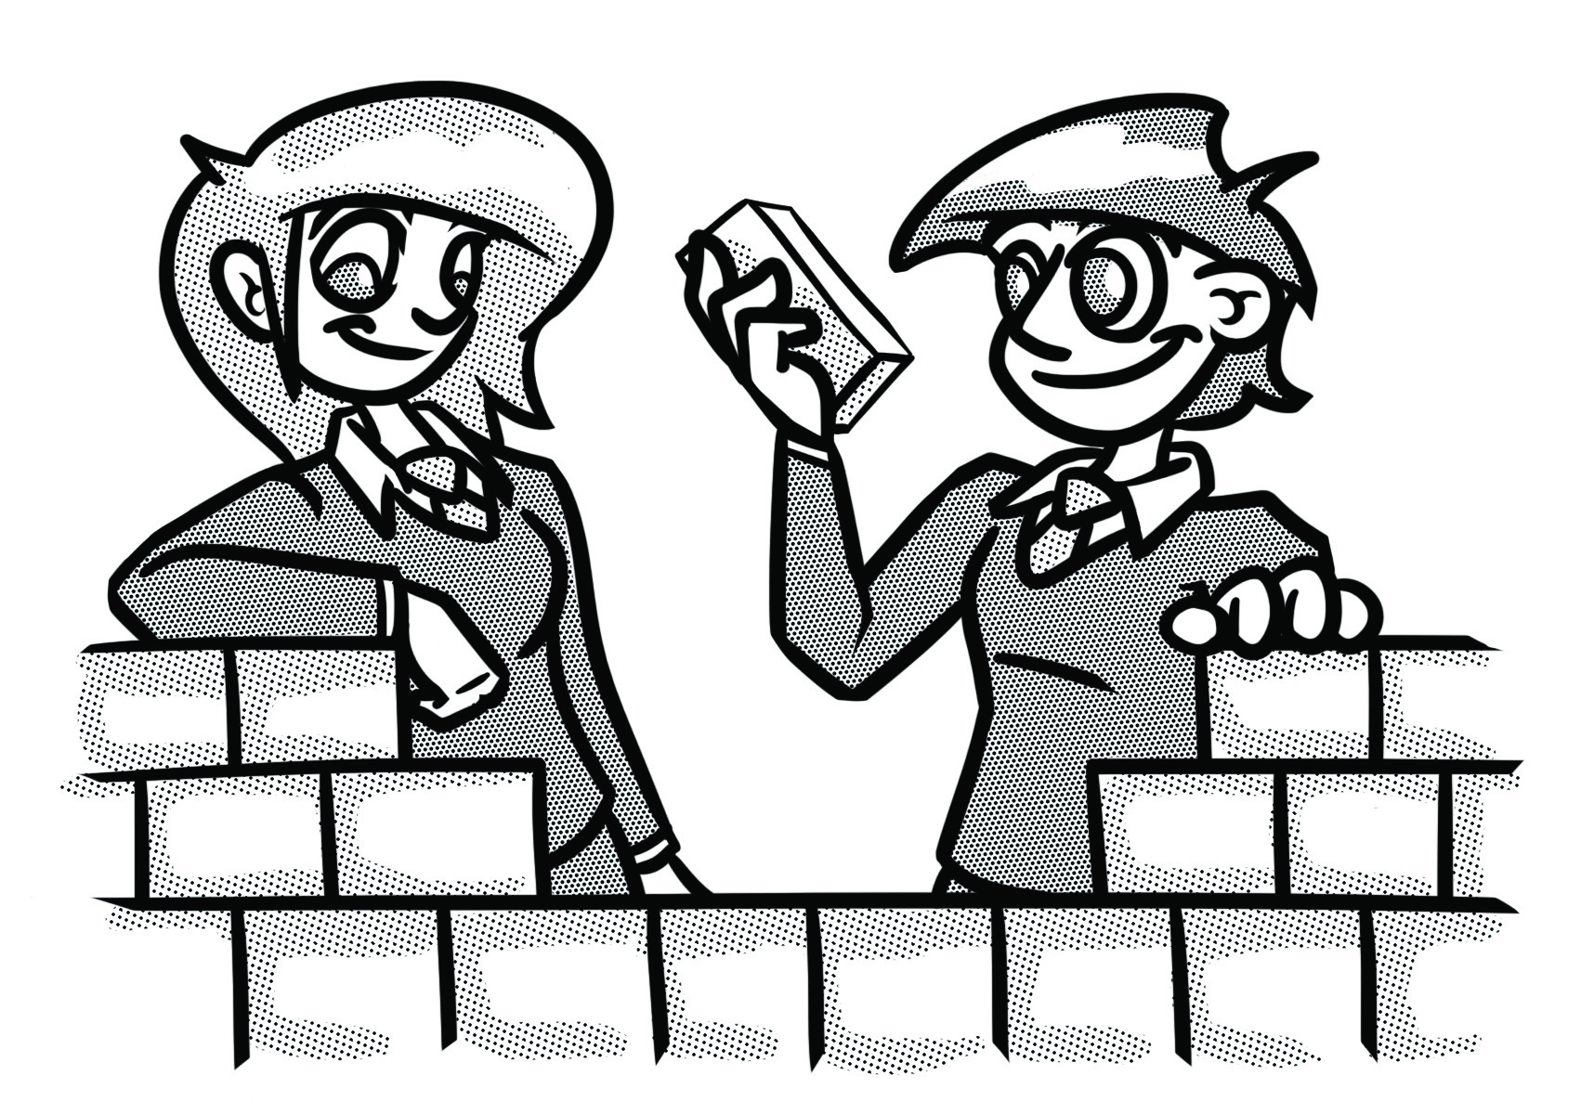

How to use this booklet
- Read the ‘recapping the foundations’ section of the booklet (see below). You can refer to this when you answer the questions.
- Answer the questions in the brick walls on pages 5 and 6 - start at the bottom of each wall.
- When you have answered the question in a brick, colour it in red, amber or green depending how confident you feel.

Recapping the foundations

Maths in physics
Standard form
Standard form numbers are often used for very large measurements (for example, distances in astronomy) or very small ones (for example, the mass of a grain of sand). Multiplying a number by a power of 10 changes the place value of each of its digits. It can make the number bigger or smaller.
A number in standard form looks like this:
$$a×{10}^{n}$$
where $1≤a<10$ and n is an integer (a “whole number”).

The decimal point appears to move by the same number of places as the index on the power of 10 (in fact, the digits move and the decimal point stays put). If a number is very small (less than 1, i.e. starting with 0. …) then the index will be a negative number.

Significant figures
Rounding numbers is intended to make them easier to work with. It is not about changing their size. If a number is rounded off, it will still be about the same size as it was before. Decimal places can be useful, but significant figures are generally the best way to round off a number in a scientific context. Remember, as with decimal places, to use the ‘deciding digit’ to decide whether to round the number down (if the ‘deciding digit’ is 4 or lower) or to round up (if the ‘deciding digit’ is 5 or higher).

To find where to round the number, start counting digits from the first non-zero digit.

Once you have started counting digits, the remaining zeros are ‘significant’, so count them.

You may need to add zeros to the end of a larger number when you round it.

Finding averages

An average of a set of data is a numerical value that summarises the data.
It is sometimes called a measure of central tendency.
There are three types of average: the mode, the median and (the most important and widely used of the three) the mean. Find each as follows:

Mode: the most frequently occurring value
Median: put the data in numerical order, then choose the middle one
$$Mean=\frac{total of items of data}{number of items of data}$$

Worked example 1
Find the mode, median and mean of 5 , 7 , 3 , 6 , 11 , 6 , 7 , 7.
Mode is 7
In order: 3 , 5 , 6 , 6 , 7 , 7 , 7 , 11
Median is 6.5 (half way between the two middle values, 6 and 7)
Total of items of data: 5 + 7 + 3 + 6 + 11 + 6 + 7 + 7 = 52
$$\frac{52 }{8}= 6.5$$
Mean = 6.5

Unit conversions
Prefix | Multiple | Standard form
giga (Gm) | 1 Gm = 1 000 000 000 m | x 10 ⁹
mega (Mm) | 1 Mm = 1 000 000 m | x 10 ⁶
kilo (km) | 1 km = 1 000 m | x 10 ³
metre (m) | 1 m | x 10 ⁰
milli (mm) | 1 mm = 0.001 m | x 10 ⁻³
micro (𝛍m) | 1 𝛍m = 0.000 001 m | x 10 ⁻⁶
nano (nm) | 1 nm = 0.000 000 001 m | x 10 ⁻⁹

Change the subject
The subject of an equation is the term that appears on its own, on one side of the equals sign. For example, in the equation F = ma, the subject is F.

Worked example 1
Make a the subject of the equation F = ma.

$$F=m×a$$
divide both sides by m
$$\frac{F}{m}=\frac{m×a}{m}$$
$$\frac{F}{m}=a or a=\frac{F}{m}$$
(Note that, in practice, this looks like changing the sign on the term that moves (here it was $×$) to its opposite ($÷$) when it moves from one side to the other. The same is true for + and − , squares and square roots, etc.)

SI units

Système International (SI) is an internationally agreed system for measurement. There are 7 base units and several other units which can be derived from them.

Measurement | Unit symbol
Time | s
Length | m
Mass | kg
Electric current | A

Strengthening the foundations
When a builder builds a brick wall, they start with the foundations at the bottom. On the wall below, the activities at the bottom are easier and they become more difficult as you move up the wall and build on the foundations you started with.
- Start with the activities at the bottom and work your way up the wall.
- RAG-rate each brick you complete by colouring it in red, amber or green to represent how confident you felt about that task.

Which of the following is the same as 1.2 GHz?  1.2 Hz, 1.2 x 10³ Hz,  1.2 x 10⁶ Hz, 1.2 x 10⁹ Hz, 1.2 x 10¹² Hz |  | Answer ‘Question A’ on page 7. |  | Explain the difference between a mean, mode and median. |  | Answer ‘Question C’ on page 8.

Arrange these numbers in order of size, starting with the largest number:  6.5 x 10⁻⁷, 7.7 x 10⁻⁹,  6.54 x 10⁻⁸, 7.8 x 10² |  | Calculate the following and write the answer in standard form:  (2.07 x 10⁶) x (7.81 x 10³)  (5 x 10⁵) x (7 x 10⁸) |  | Calculate $\sqrt{75}$ to 2 s.f. |  | Round 5.746396 to 1 d.p., 2 d.p., 3 d.p. and 4 d.p.

Convert the following into grams and write the answer in standard form:  2400 kg and 0.00003kg |  | Some radio waves have a frequency of 1 200 000 000 Hz. Convert this number to standard form. |  | Calculate the mean of the following masses and express the answer to a suitable number of s.f.:  7.3, 6.9, 7.4, 7.1, 7.7 |  | How many significant figures does 0.776728000 have?
Express the following numbers in standard form:  568054, 0.00201090, 5678 |  | Write the following in standard form: six million, two hundred thousand, one thousand one hundred and sixty-three. |  | Write 50034.745 to 1 s.f., 2 s.f., 3 s.f. and 4 s.f. |  | Round the following to 2 significant figures:  356, 87301, 0.00001931

Learn the first 15 physics equations on the equation sheet. |  | Answer ‘Question B’ on page 7. |  | Explain how to calculate acceleration and the distance travelled using a velocity-time graph. |  | Change the subject of the following equation to find ‘v’.  KE = ½ m v²

A sound wave has a frequency of 25.0 kHz and a wavelength of 0.0139 m. Calculate the wave speed.  Give your answer to 3 s.f. |  | Explain the difference between mass and weight. Include units and how you would measure each of them. |  | Draw a transverse wave. Label the wavelength and amplitude of the wave. Explain how you would find the frequency of the wave. |  | Change the subject of the following equation to find ‘a’.  F = m x a

Learn the first 10 physics equations on the equation sheet. |  | State the unit for each of the following quantities: power, resistance, energy, work done, force and potential difference. |  | Define the terms refraction and reflection. You can use a diagram in your explanation. |  | Draw and label a series circuit containing five components. The circuit must contain a bulb and a battery or power pack.

Learn the first 5 physics equations on the equation sheet. |  | Name the SI unit for length, mass, time and electric current. |  | Convert the following numbers to metres:  1km, 1mm, 1Mm, 1nm |  | Sketch as many circuit symbols for electrical components as you can remember and correctly label them.

Question A
Look at the diameter of the planets in the table below.

Planet | Diameter/km
Mercury | 4 878
Venus | 12 100
Earth | 12 756
Mars | 6 752

- Convert all the diameters to standard form to 2 s.f.
- Calculate the difference in size between the diameter of Earth and the diameter of Mars. Give your answer in standard form.
- The diameter of the Moon is 3.5 x 10³ km. Give the ratio of the Moon to the Earth.

Question B
Describe an experiment to determine how the length of a wire affects resistance. You should include a circuit diagram, method and the equation linking resistance, potential difference and current.

Question C
Plot the following points on the graph paper provided.

- Draw an appropriate line of best fit.
- Use your graph to estimate the magnification at a distance of 45 cm.

Distance between object and lens/cm | Magnification
25 | 4.0
30 | 2.0
40 | 1.0
50 | 0.7
60 | 0.5

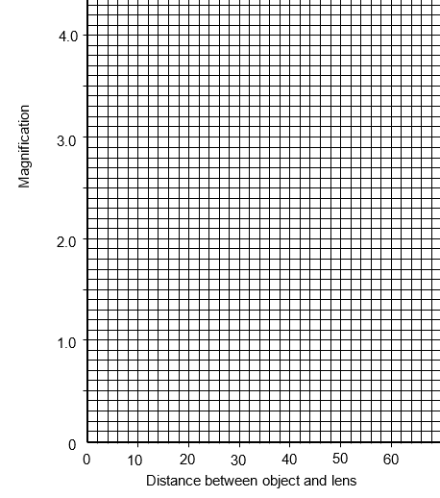

© Commissioned by The PiXL Club Ltd. July 2020

This resource is strictly for the use by The PiXL Club Ltd member schools during the life of the membership only. It may NOT be copied, sold, or transferred or made available by whatever means to a third-party non-member during or after membership. Until such time it may be freely used within the PiXL member school by their teachers and authorized staff and any other use or sale thereof is strictly prohibited.

All opinions and contributions are those of the authors. The contents of this resource are not connected with, or endorsed by, any other company, organisation or institution.

PiXL Club Ltd endeavour to trace and contact copyright owners. If there are any inadvertent omissions or errors in the acknowledgements or usage, this is unintended and PiXL will remedy these on written notification.

