Strengthening the Foundations Workbook
KS4 Chemistry
Students will need a copy of the examination board periodic table.

Hello!

Even in the best of times, not everything goes to plan. Things happen – things we cannot control - which affect our learning. It is nothing to worry about. We all have strengths and weaknesses; we all have to work hard to achieve our goals. Remember, your teachers know what you are good at and they know what you find difficult. They will support you.

In all subjects you learn at school, or college, there are important concepts and ideas which help you to understand a topic and provide the foundations for future learning. If you don’t have solid foundations, the rest of your knowledge will be unstable and not as secure as it could otherwise be.

The purpose of this workbook is to make sure your foundations are stable so that you can build the rest of your learning on it and have the strongest bank of knowledge and skills as possible.

Creating a stable foundation takes regular practice. We hope that this booklet will help you on your journey.

So, let’s practise!

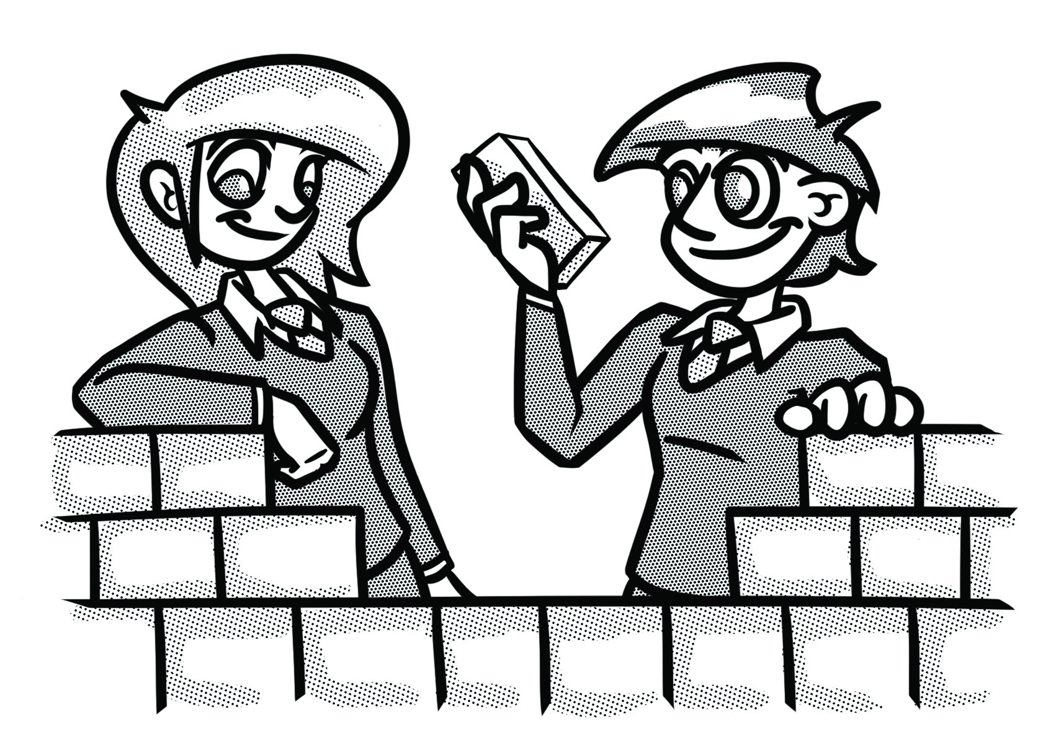

How to use this booklet.
- Read the ‘recapping the foundations’ section of the booklet (see below). You can refer to this when you answer the questions.
- Answer the questions in the brick walls on pages 5 and 6 - start at the bottom of each wall.
- When you have answered the question in a brick, colour it in red, amber or green depending how confident you feel.

Recapping the foundations

Maths in chemistry
Standard form
Standard form numbers are often used for very large measurements (for example, distances in astronomy) or very small ones (for example, the mass of a grain of sand). Multiplying a number by a power of 10 changes the place value of each of its digits. It can make the number bigger or smaller.
A number in standard form looks like this:
$$a×{10}^{n}$$
where $1≤a<10$ and n is an integer (a “whole number”).

The decimal point appears to move by the same number of places as the index on the power of 10 (in fact, the digits move and the decimal point stays put). If a number is very small (less than 1, i.e. starting with 0. …) then the index will be a negative number.

Significant figures
Rounding numbers is intended to make them easier to work with. It is not about changing their size. If a number is rounded off, it will still be about the same size as it was before. Decimal places can be useful, but significant figures are generally the best way to round off a number in a scientific context. Remember, as with decimal places, to use the ‘deciding digit’ to decide whether to round the number down (if the ‘deciding digit’ is 4 or lower) or to round up (if the ‘deciding digit’ is 5 or higher).

To find where to round the number, start counting digits from the first non-zero digit.

Once you have started counting digits, the remaining zeros are ‘significant’, so count them.

You may need to add zeros to the end of a larger number when you round it.

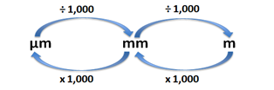
Converting units
1000 cm³ = 1 dm³
cm³ ÷ 1000 = dm³
dm³ x 1000 = cm³

Balancing equations
To balance an equation:
- Check to see if the numbers of atoms of each element on the left is the same as the number on the right.
- Deal with only one element at a time.
- You cannot change any of the small numbers in a chemical formula. If balancing is required, put the number in front of the substance.
More oxygen is needed so add an H₂O
H₂ + O₂ H₂O
H x 2
O x 1
H x 2
O x 2

More hydrogen is needed so add an H₂
H₂ + O₂ 2H₂O
H x 4
O x 2
H x 2
O x 2

2H₂ + O₂ 2H₂O
H x 4
O x 2
H x 4
O x 2

Relative formula mass
The relative formula mass (Mr) of a compound is the sum of the relative atomic masses (Ar) of the atoms in the numbers shown in the formula. The relative atomic masses can be found in the periodic table.
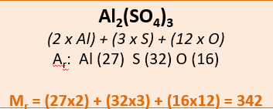
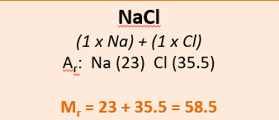

Mass number and atomic number
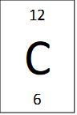
Atomic or proton number = number of protons
Relative atomic mass (Ar) = mass of protons + neutrons

Atoms, ions and charge
In an atom the number of protons equals the number of electrons so there is no overall charge. In a positive ion there are more protons than electrons, e.g. in a Ca²⁺ ion there are two more protons than electrons. In a negative ion there are more electrons than protons, e.g. in a O²⁻ ion there are two more electrons than protons.

Strengthening the foundations
When a builder builds a brick wall, they start with the foundations at the bottom. On the wall below, the activities at the bottom are easier and they become more difficult as you move up the wall and build on the foundations you started with.
- Start with the activities at the bottom and work your way up the wall.
- RAG-rate each brick you complete by colouring it in red, amber or green to represent how confident you felt about that task.

Choose an element in Group 1 of the periodic table. Use the mass number and atomic number to describe an atom of this element. |  | Complete ‘Question D’ on page 8. |  | Explain how to test for the following gases: hydrogen, oxygen, carbon dioxide and chlorine. |  | Complete ‘Question C’ on page 8.

Arrange these numbers in order of size, starting with the largest number:  6.5 x 10⁻⁷, 7.7 x 10⁻⁹,  6.54 x 10⁻⁸, 7.8 x 10² |  | Calculate the following and write the answer in standard form:  - (3 x 10⁵) ÷ (5 x 10⁻³)  - (4 x 10⁴)² |  | Convert the following:  a) 38743 cm³ to dm³  b) 0.576 dm³ to cm³  c) 756294 cm³ to dm³ |  | Round 7.25392 to 1 d.p., 2 d.p., 3 d.p. and 4 d.p.

Convert the following into grams and write the answer in standard form:  73902 kg and 0.00034kg |  | The Avogadro constant is  6.02 x10²³. Write this as an ordinary number. Explain why we use standard form for this number. |  | Round these numbers to  4 s.f.:  835.975, 0.00387295, 9740389.97, 0.00372562 |  | How many significant figures does 0.7639200 have?
Express the following numbers in standard form:  67985, 0.0000652, 5678 |  | Write the following in standard form: five million, three hundred thousand, two thousand five hundred and seventy-two. |  | Write 79605.962 to 1 s.f., 2 s.f., 3 s.f. and 4 s.f. |  | Round the following to 2 significant figures:  791, 35964, 0.0007916

Higher Tier: State the equation linking moles, mass and relative formula mass. |  | Higher Tier: State the equation linking concentration moles and volume. |  | Higher Tier: Write a method for carrying out a titration to find the concentration of an unknown solution. Draw and label the equipment. |  | Higher Tier: Complete ‘Question B’ on page 7.

Write a balanced symbol equation, with state symbols, for the reaction between hydrochloric acid and CuCO₃. |  | Write a method to make pure, dry crystals of copper sulfate using the equipment and chemicals in ‘Diagram A’ on page 8. |  | Draw an atom and an ion (Mg²⁺) of magnesium. Include the shells of electrons. Label the subatomic particles. |  | Calculate the relative formula mass of the following:  NH₄NO₃, MgSO₄, Ca(Al₂Si₂)O₈

Balance the following equations:  NH₃ + H₂SO₄ (NH₄)₂SO₄  C₃H₈ + O₂ CO₂ + H₂O |  | Name the equipment in ‘Diagram A’ on page 8. |  | Explain the difference between an atom, a molecule and an ion by using oxygen as your example. |  | Describe the following molecule in words: (NH₄)₂SO₄

Balance the following equations:  N₂ + H₂ NH₃  Mg + O₂ MgO  CH₄ + O₂ H₂O + CO₂ |  | Complete ‘Question A’ on page 7. |  | Calculate the relative formula mass of the following:  H₂O, CH₄, NH₃, HCl, H₂SO₄ |  | Describe the following molecule in words: H₂SO_{4,}  e.g. CO₂ contains one carbon and two oxygen atoms.

Question A
Look at the following graph showing the time taken for a reaction to occur at different temperatures.
- Draw a line of best fit.
- Describe the trend.
- Explain the trend.

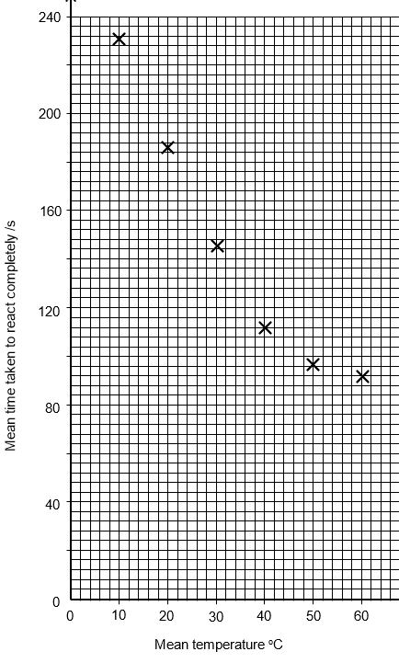

Question B
Calculate the concentration (mol/dm³) for the following (some questions will require you to convert the units):
Show all of your workings to a maximum of 2.d.p.
- 0.65mol of HCl in 2dm³ water
- 2mol of H₂SO₄ in 2dm³ water
- 2mol NaOH in 0.75dm³ water
- 2mol NaOH in 100cm³ water
- 0.5 mol HCl in 1500cm³ water

Question C
The box below has been taken from the periodic table. It contains information about an element.
Write down as much information about this element as possible.
Remember to use the two numbers to help you.

35.5
Cl
17

Question D
Look at the following method for chromatography.
- Draw a pencil line across the chromatography paper about 1 - 2 cm from the bottom.
- Use a pipette or capillary tube to add small spots of each ink to the line on the paper.
- Place the paper into a container with a suitable solvent in the bottom.
- Allow the solvent to move through the paper, but remove the chromatogram before it reaches the top.
- Allow the chromatogram to dry, then measure the distance travelled by each spot and by the solvent.

For each step in the above method, list the equipment needed and explain why that step is needed.

Diagram A

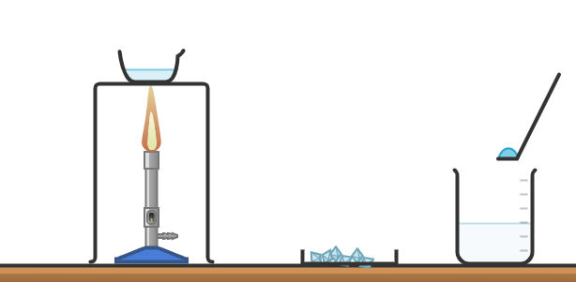
Diagram made in Chemix

© Commissioned by The PiXL Club Ltd. July 2020

This resource is strictly for the use by The PiXL Club Ltd member schools during the life of the membership only. It may NOT be copied, sold, or transferred or made available by whatever means to a third-party non-member during or after membership. Until such time it may be freely used within the PiXL member school by their teachers and authorized staff and any other use or sale thereof is strictly prohibited.

All opinions and contributions are those of the authors. The contents of this resource are not connected with, or endorsed by, any other company, organisation or institution.

PiXL Club Ltd endeavour to trace and contact copyright owners. If there are any inadvertent omissions or errors in the acknowledgements or usage, this is unintended and PiXL will remedy these on written notification.

